Technical Documentation of

Inventory Load flow in OMS

Service: IBD_UpdateInventory_Async

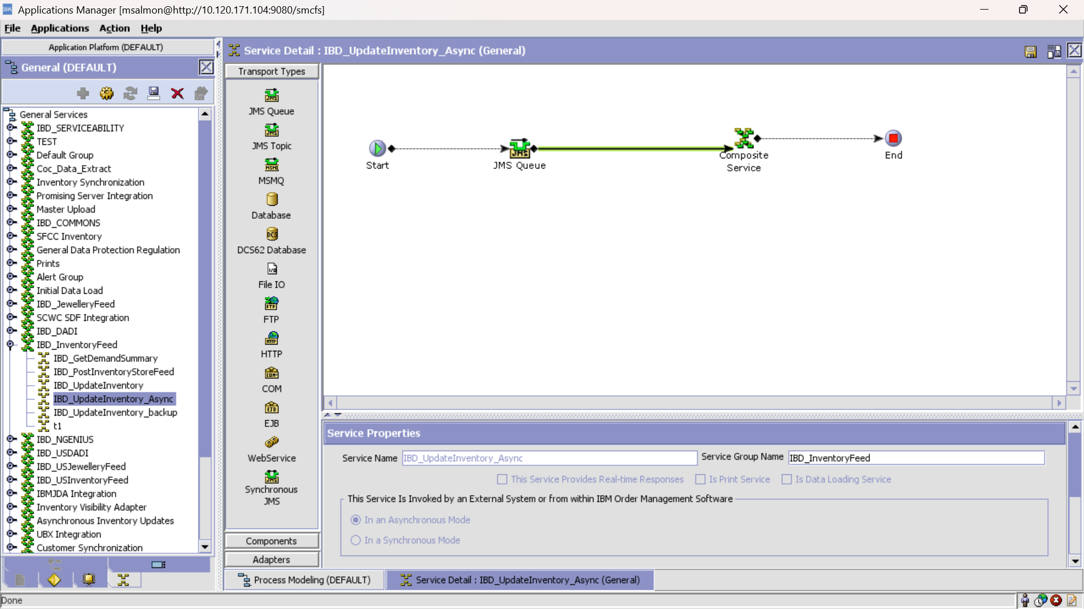

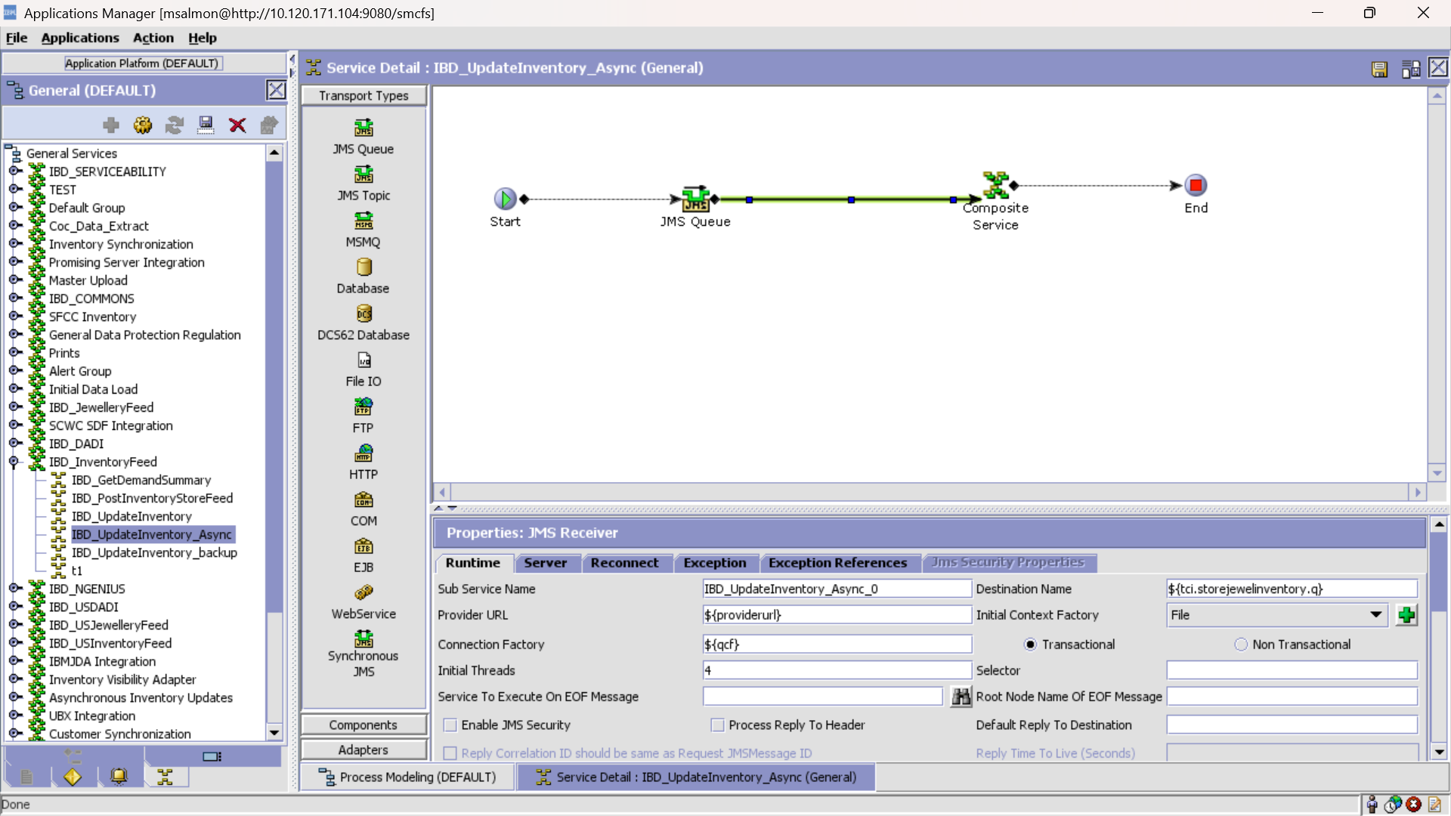

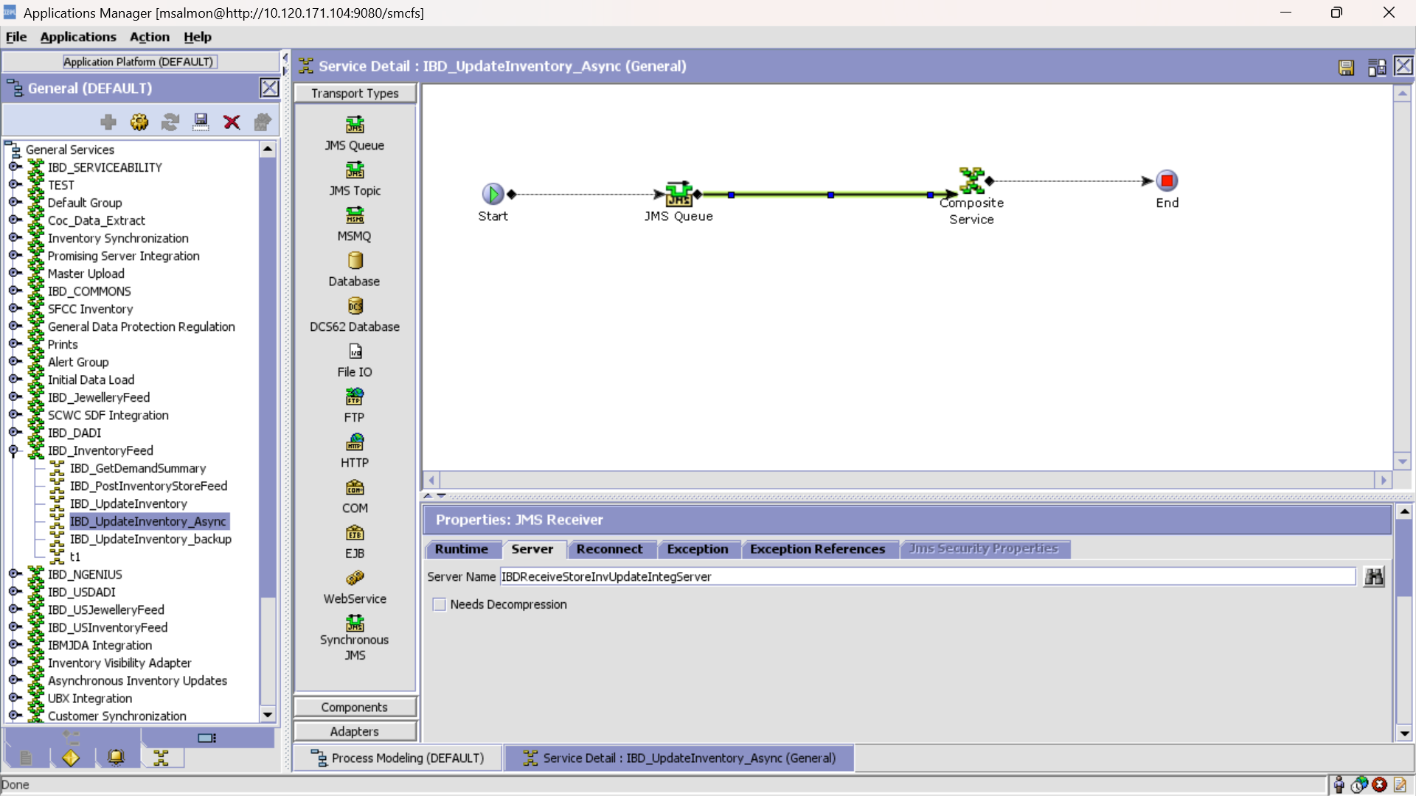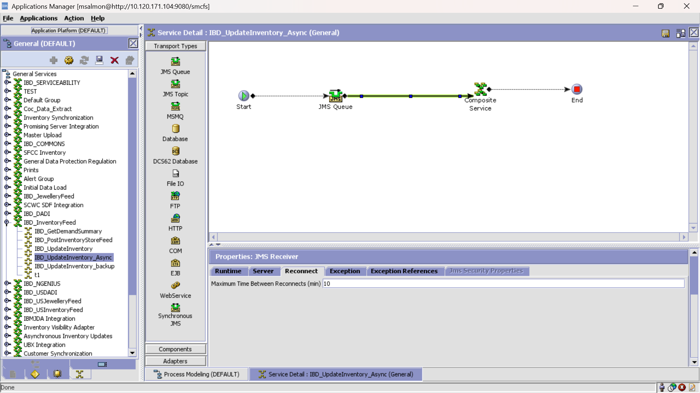

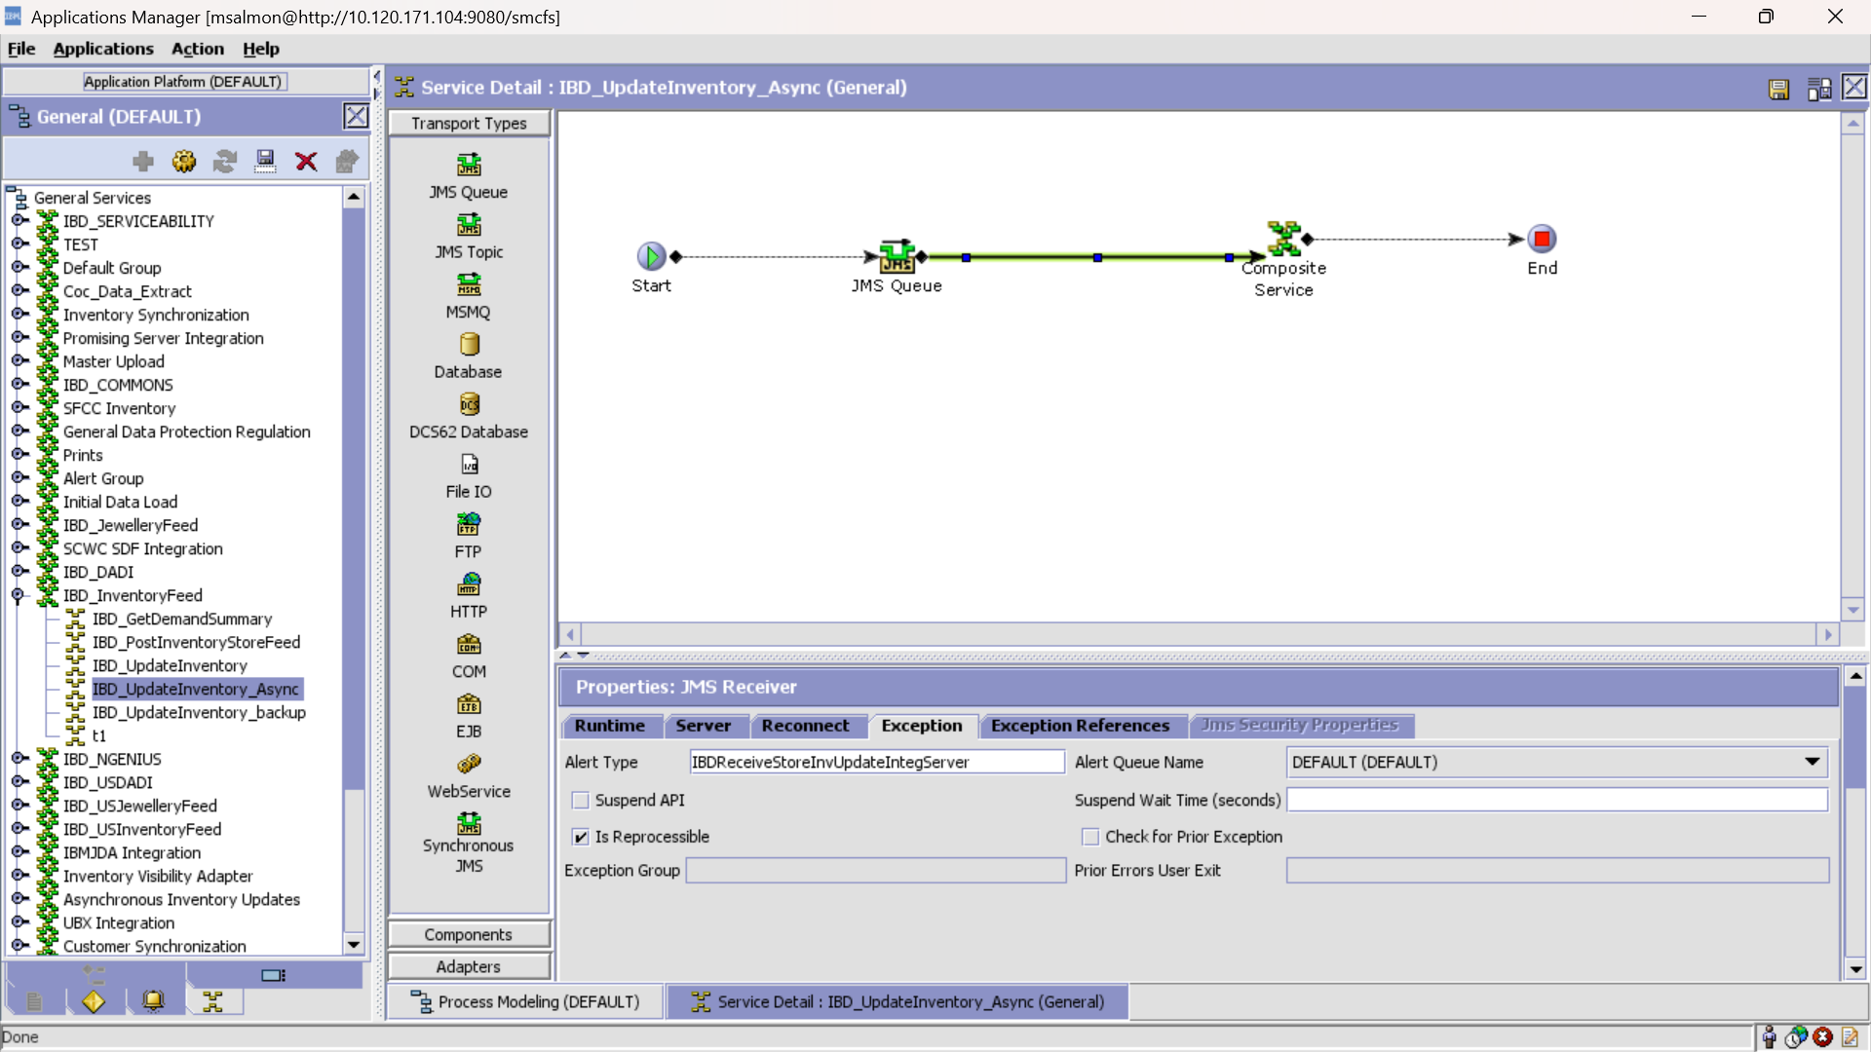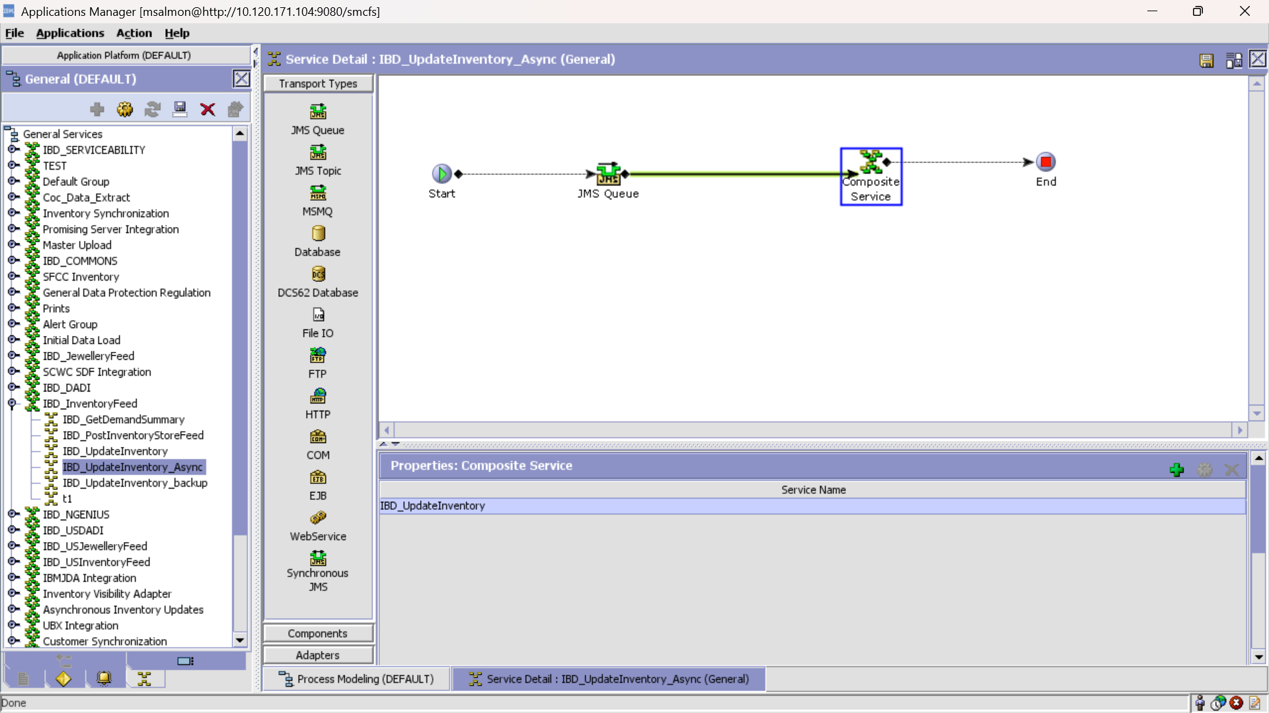Service Invoked in composite service IBD_UpdateInventory configurations defined below

Service: IBD_UpdateInventory

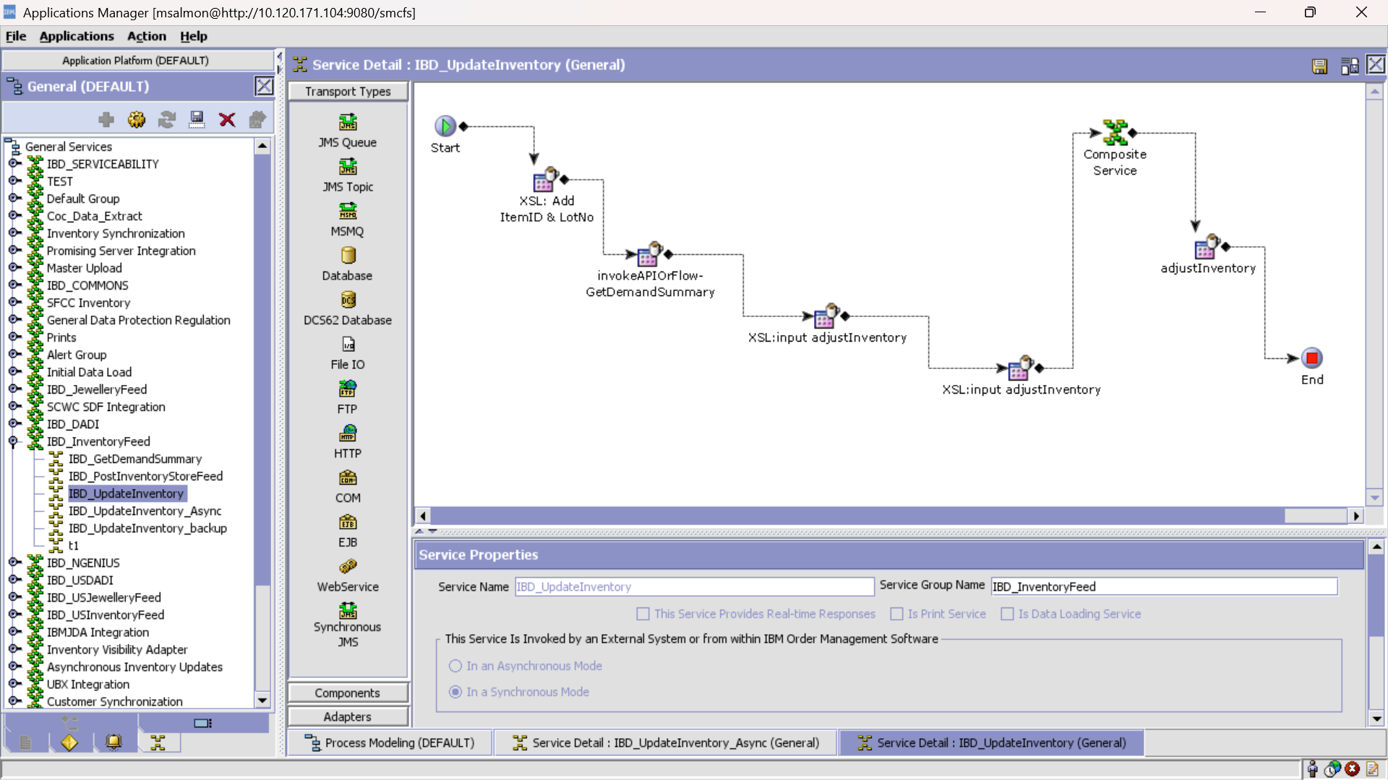

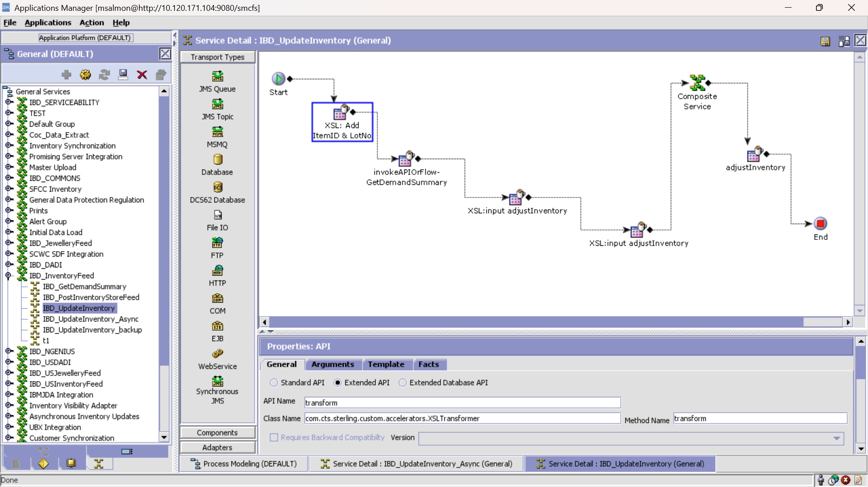

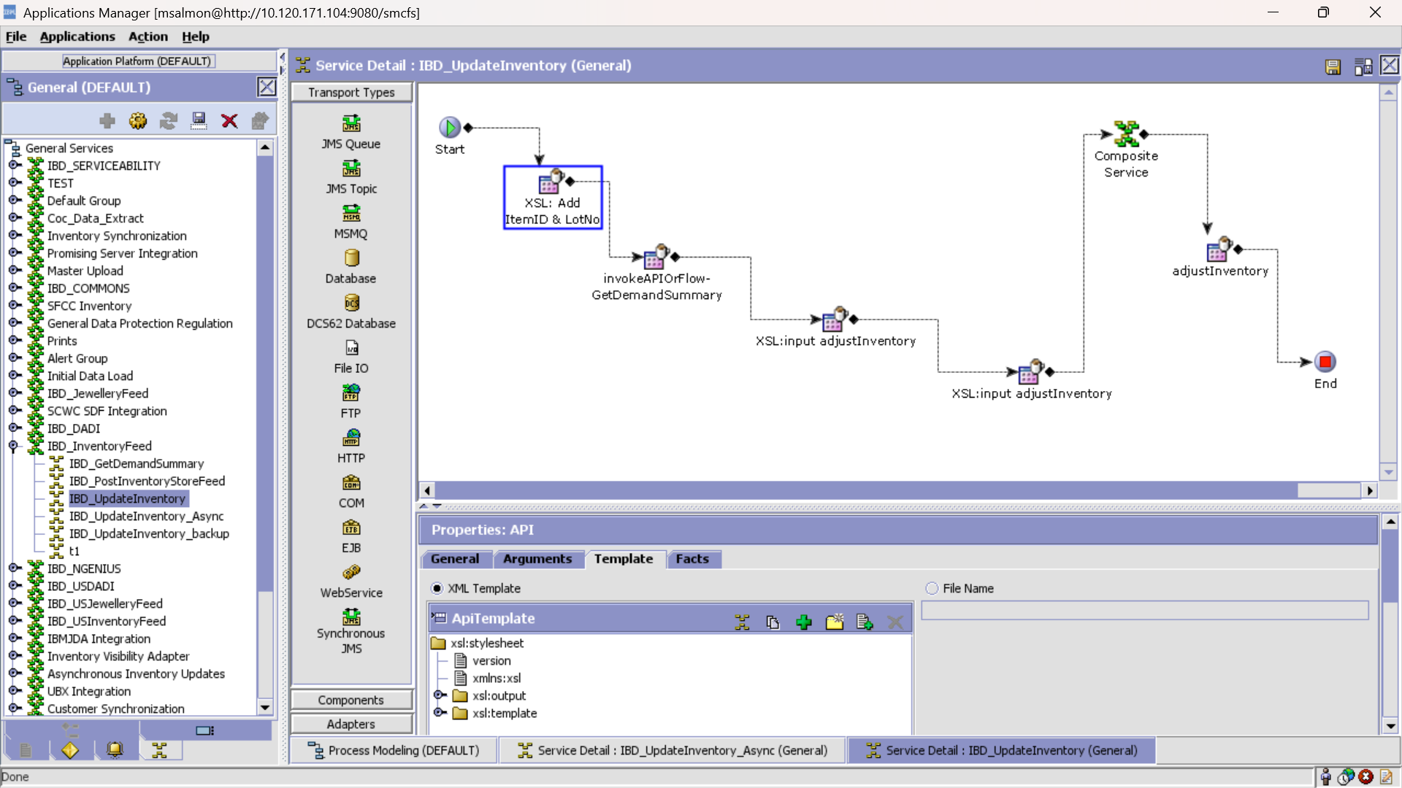

XSL :

<?xml version="1.0" encoding="UTF-8"?>

<xsl:stylesheet version="1.0" xmlns:xsl="http://www.w3.org/1999/XSL/Transform">

<xsl:output encoding="UTF-8" indent="yes" method="xml" omit-xml-declaration="yes"/>

<xsl:template match="/InventorySnapShot">

<InventorySnapShot>

<xsl:attribute name="InventoryFeedType">

<xsl:value-of select="@InventoryFeedType"/>

</xsl:attribute>

<xsl:attribute name="OrganizationCode">

<xsl:value-of select="@OrganizationCode"/>

</xsl:attribute>

<xsl:attribute name="StatusDate">

<xsl:value-of select="@StatusDate"/>

</xsl:attribute>

<xsl:for-each select="ShipNode">

<ShipNode>

<xsl:attribute name="ShipNode">

<xsl:value-of select="@ShipNode"/>

</xsl:attribute>

<Item>

<xsl:attribute name="ItemID">

<xsl:value-of select="concat(Item/@ItemID,Item/@LotNumber)"/>

</xsl:attribute>

<xsl:attribute name="LotNumber">

<xsl:value-of select="Item/@LotNumber"/>

</xsl:attribute>

<xsl:attribute name="CFAProductCode">

<xsl:value-of select="Item/@CFAProductCode"/>

</xsl:attribute>

<SupplyDetails>

<xsl:attribute name="Quantity">

<xsl:value-of select="Item/SupplyDetails/@Quantity"/>

</xsl:attribute>

</SupplyDetails>

</Item>

</ShipNode>

</xsl:for-each>

</InventorySnapShot>

</xsl:template>

</xsl:stylesheet>

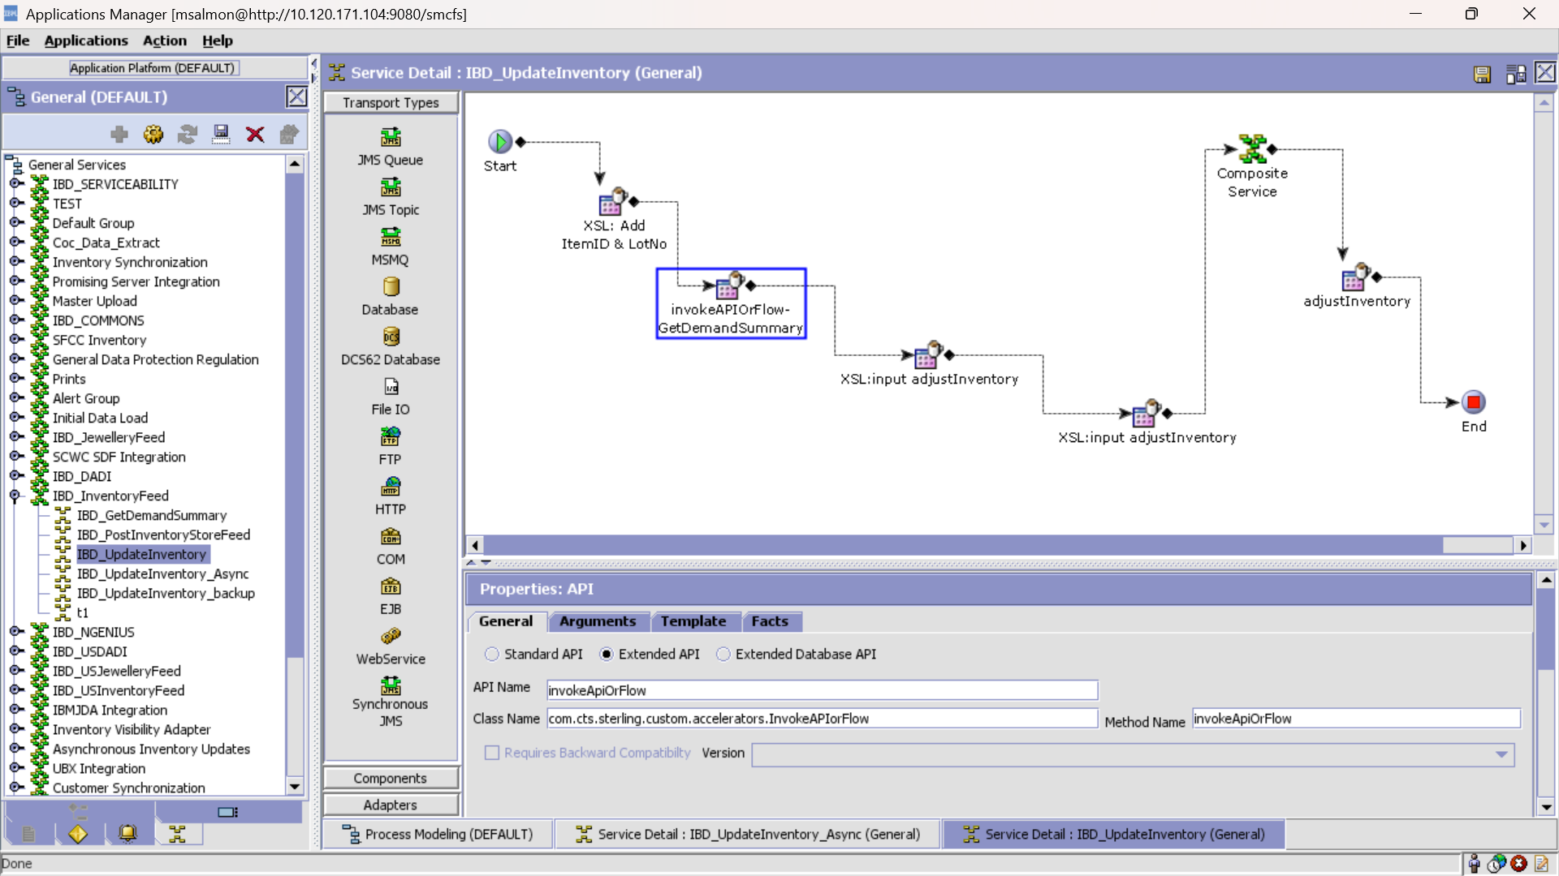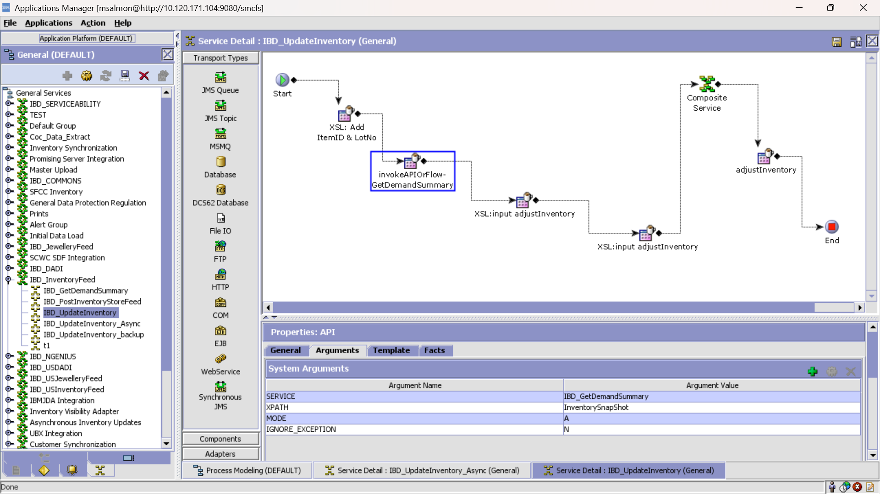Service IBD_GetDemandSummary invoked here is defined in page 16

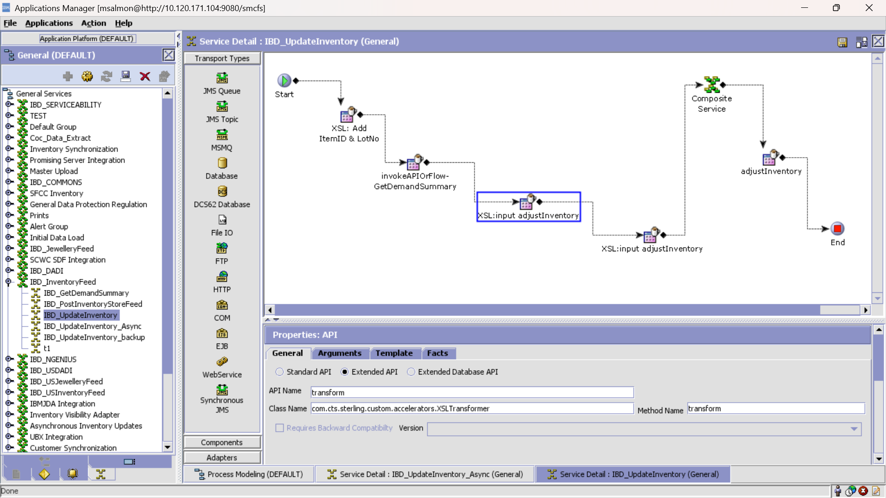

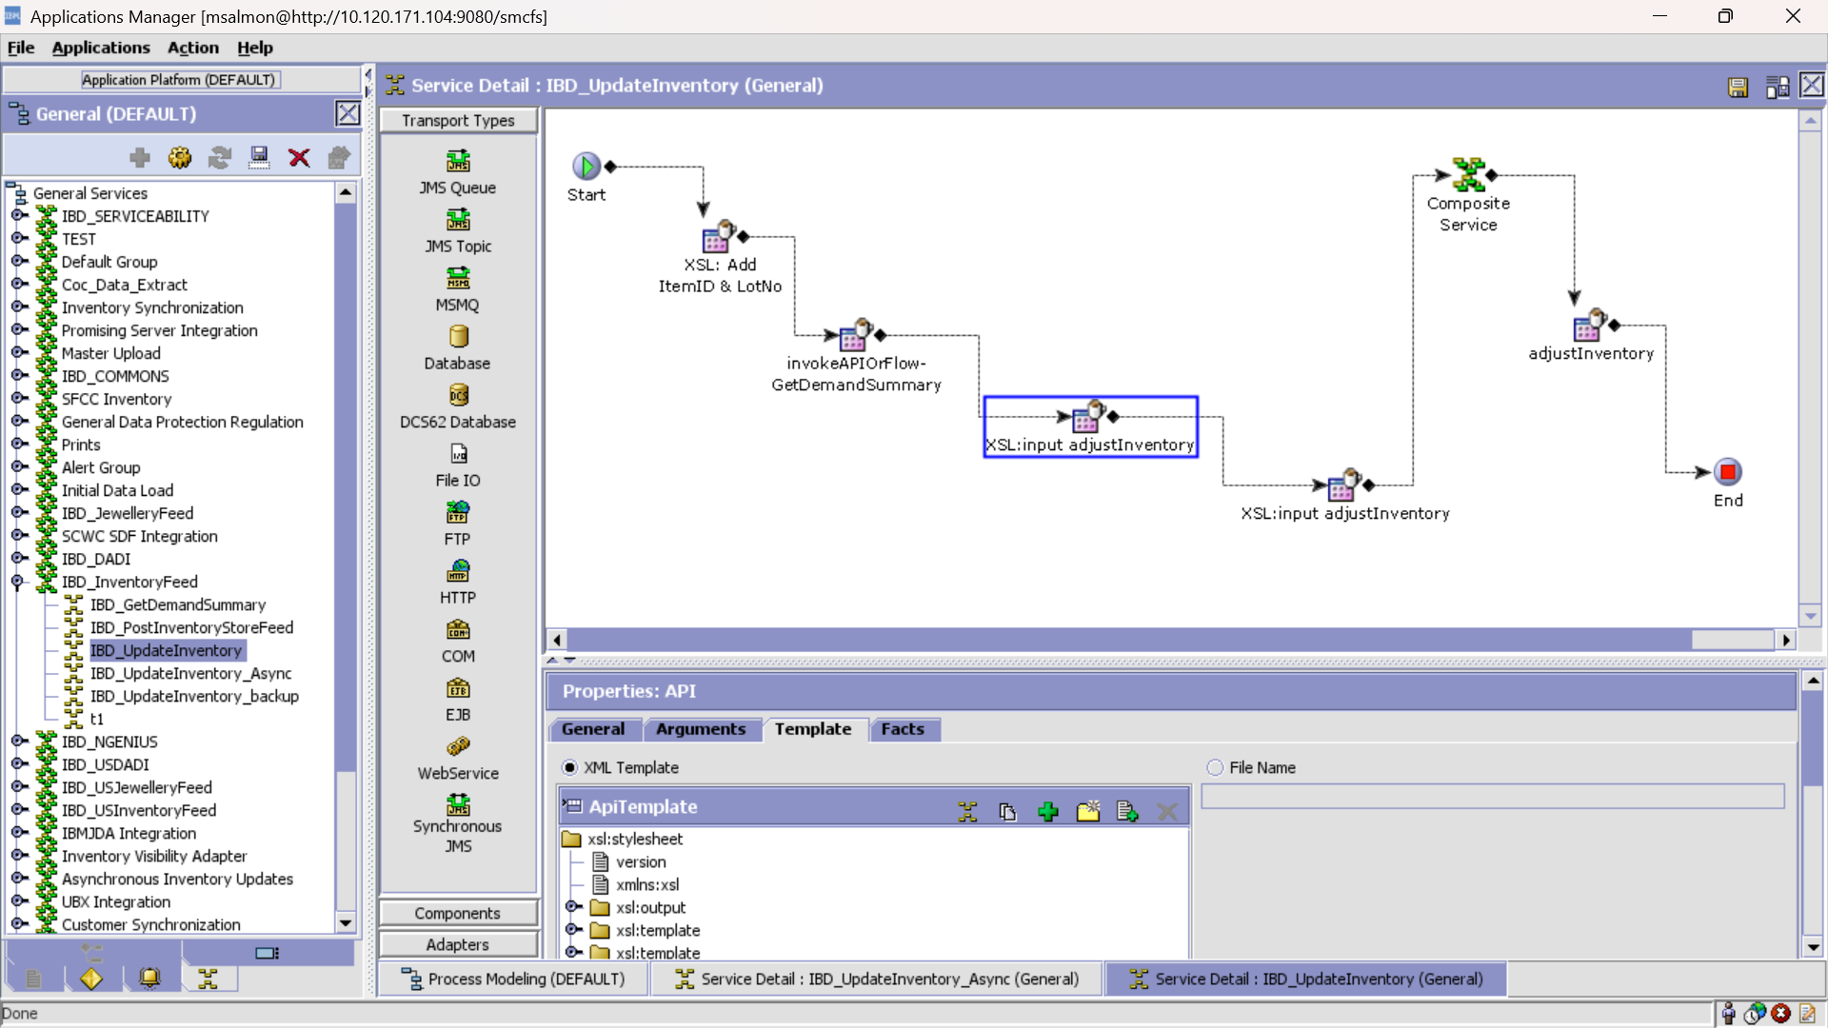

XSL:

<?xml version="1.0" encoding="UTF-8"?>

<xsl:stylesheet version="1.0" xmlns:xsl="http://www.w3.org/1999/XSL/Transform">

<xsl:output indent="yes" method="xml"/>

<xsl:template match="@*|node()">

<xsl:copy>

<xsl:apply-templates select="@*|node()"/>

</xsl:copy>

</xsl:template>

<xsl:template match="/">

<Items>

<Item>

<xsl:choose>

<xsl:when test="InventorySnapShot/ShipNode/Item/SupplyDetails/@Quantity &lt; '0'">

<xsl:attribute name="SupplyQty">

<xsl:value-of select="'0'"/>

</xsl:attribute>

</xsl:when>

<xsl:otherwise>

<xsl:attribute name="SupplyQty">

<xsl:value-of select="InventorySnapShot/ShipNode/Item/SupplyDetails/@Quantity"/>

</xsl:attribute>

</xsl:otherwise>

</xsl:choose>

<!-- Quantity1 and Quantity2, will help us to calculate the supply quantity in next xsl component.

If Quantity1 and Quantity2 remains zero, that means there were no 'ORDER_PACKED' and 'ORDER_ACCEPTED' demands.

It also means that there we no demand, this is a fresh inventory load. -->

<xsl:attribute name="Quantity1">

<xsl:value-of select="'0'"/>

</xsl:attribute>

<xsl:attribute name="Quantity2">

<xsl:value-of select="'0'"/>

</xsl:attribute>

<xsl:for-each select="/InventorySnapShot/DemandSummary/Demand">

<xsl:if test="@DemandType='ORDER_PACKED.ex'">

<xsl:attribute name="Quantity1">

<xsl:value-of select="@Quantity"/>

</xsl:attribute>

</xsl:if>

<xsl:if test="@DemandType='ORDER_ACCEPTED.ex'">

<xsl:attribute name="Quantity2">

<xsl:value-of select="@Quantity"/>

</xsl:attribute>

</xsl:if>

</xsl:for-each>

<xsl:attribute name="ItemID">

<xsl:value-of select="InventorySnapShot/ShipNode/Item/@ItemID"/>

</xsl:attribute>

<xsl:attribute name="ShipNode">

<xsl:value-of select="InventorySnapShot/ShipNode/@ShipNode"/>

</xsl:attribute>

<xsl:attribute name="AdjustmentType">

<xsl:text>ABSOLUTE</xsl:text>

</xsl:attribute>

<xsl:attribute name="UnitOfMeasure">

<xsl:text>EACH</xsl:text>

</xsl:attribute>

<xsl:attribute name="ProductClass">

<xsl:text>FQ</xsl:text>

</xsl:attribute>

<xsl:attribute name="SupplyType">

<xsl:text>ONHAND</xsl:text>

</xsl:attribute>

</Item>

</Items>

</xsl:template>

</xsl:stylesheet>

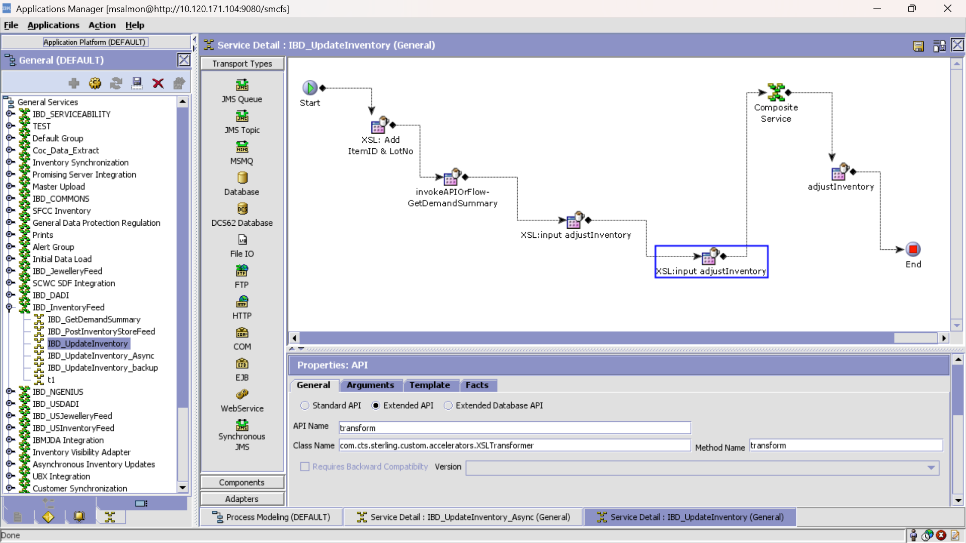

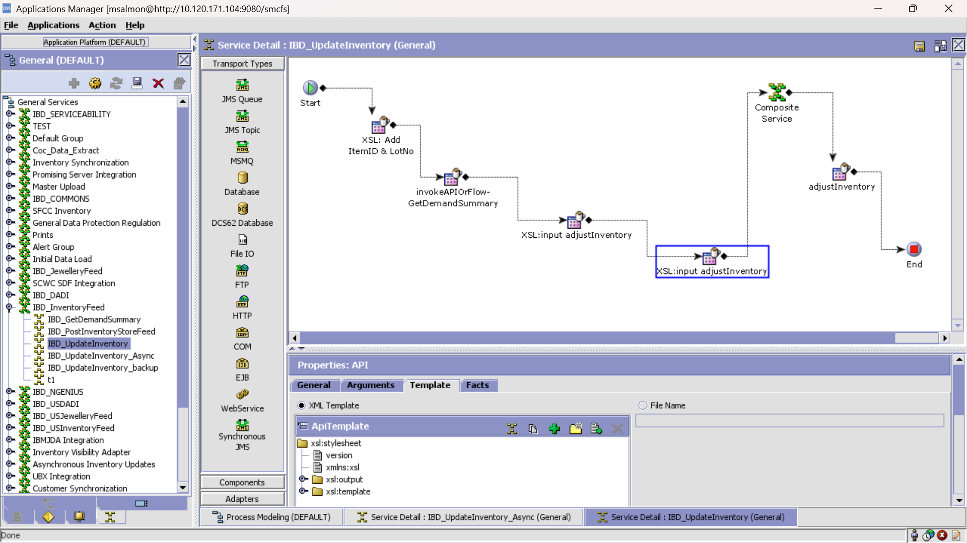

XSL:

<?xml version="1.0" encoding="UTF-8"?>

<xsl:stylesheet version="1.0" xmlns:xsl="http://www.w3.org/1999/XSL/Transform">

<xsl:output encoding="UTF-8" indent="yes" method="xml" omit-xml-declaration="yes"/>

<xsl:template match="Items/Item">

<Items>

<Item>

<xsl:attribute name="ItemID">

<xsl:value-of select="@ItemID"/>

</xsl:attribute>

<xsl:attribute name="ShipNode">

<xsl:value-of select="@ShipNode"/>

</xsl:attribute>

<xsl:attribute name="AdjustmentType">

<xsl:value-of select="@AdjustmentType"/>

</xsl:attribute>

<xsl:attribute name="UnitOfMeasure">

<xsl:value-of select="@UnitOfMeasure"/>

</xsl:attribute>

<xsl:attribute name="ProductClass">

<xsl:value-of select="@ProductClass"/>

</xsl:attribute>

<xsl:attribute name="SupplyType">

<xsl:value-of select="@SupplyType"/>

</xsl:attribute>

<xsl:if test="(@Quantity1!='0' or @Quantity2!='0')">

<xsl:attribute name="Quantity">

<xsl:value-of select="(@Quantity1 + @Quantity2 + @SupplyQty)"/>

</xsl:attribute>

</xsl:if>

<xsl:if test="(@Quantity1='0' and @Quantity2='0')">

<xsl:attribute name="Quantity">

<xsl:value-of select="@SupplyQty"/>

</xsl:attribute>

</xsl:if>

</Item>

</Items>

</xsl:template>

</xsl:stylesheet>

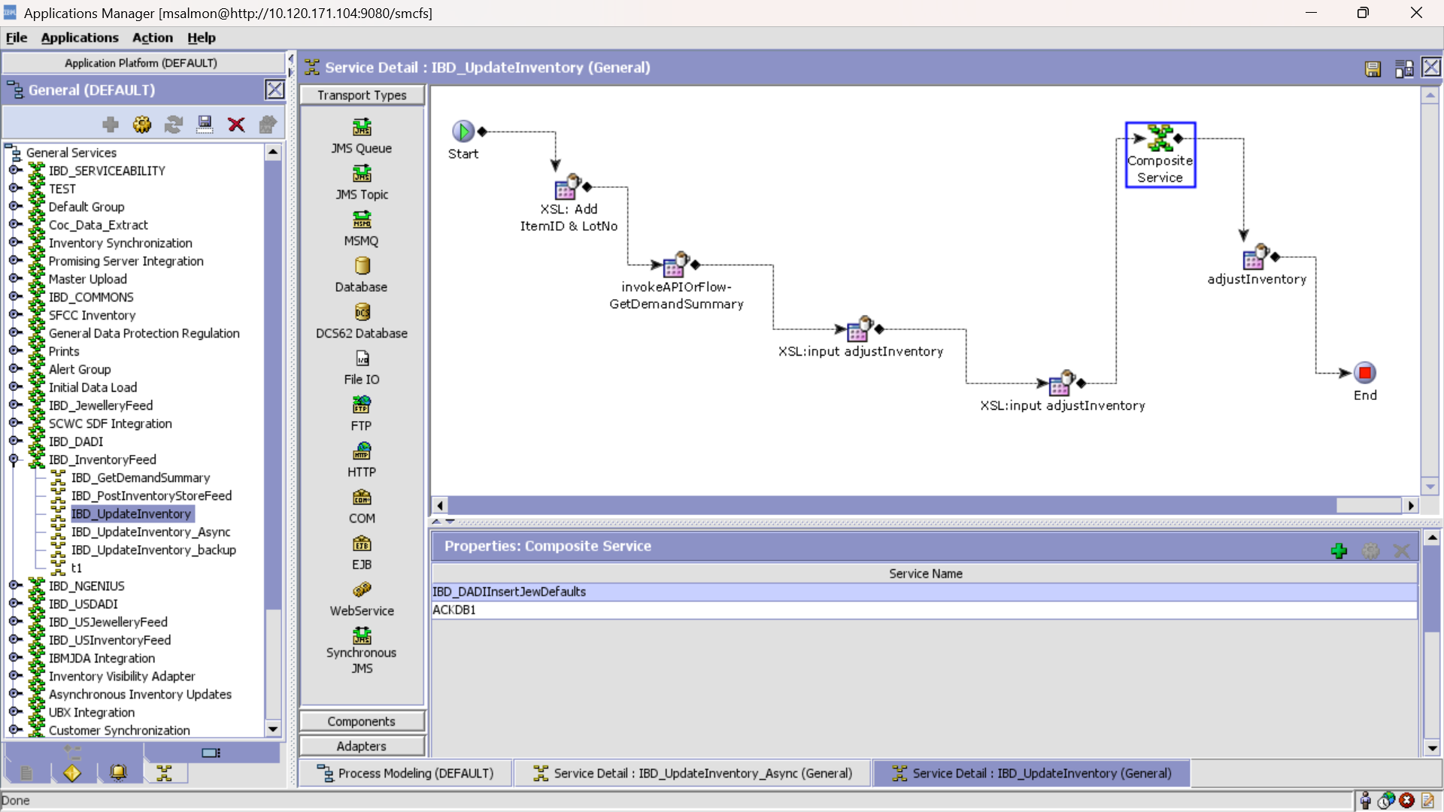Service IBD_DADIInsertJewDefaults invoked here is defined in page

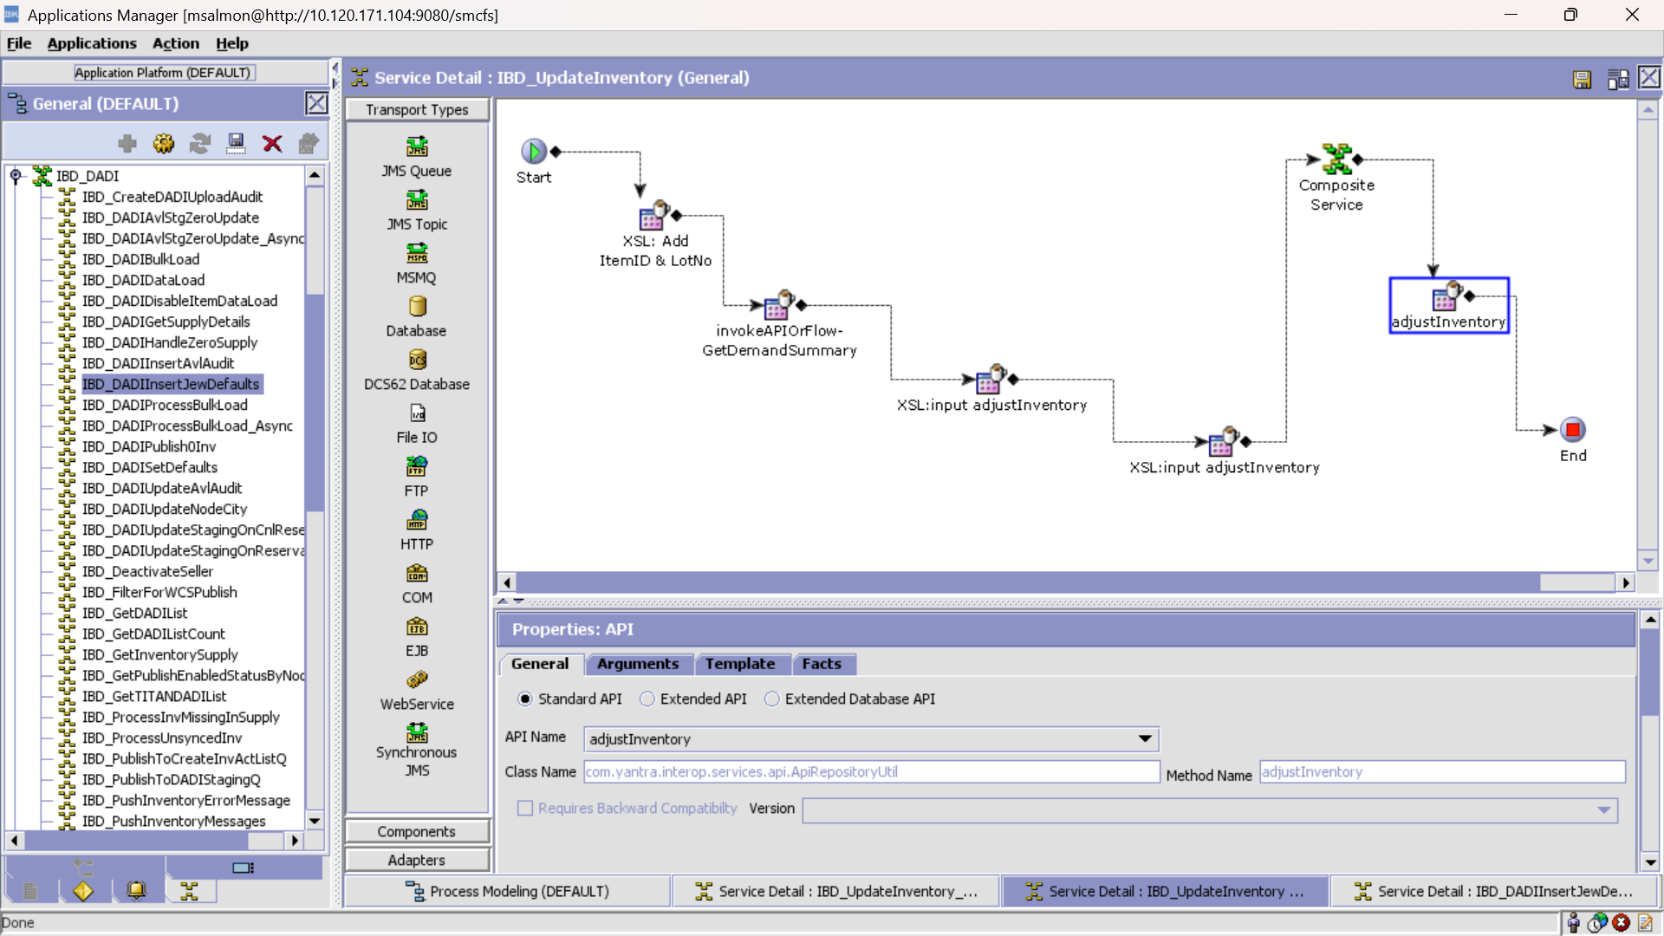

Service : IBD_GetDemandSummary

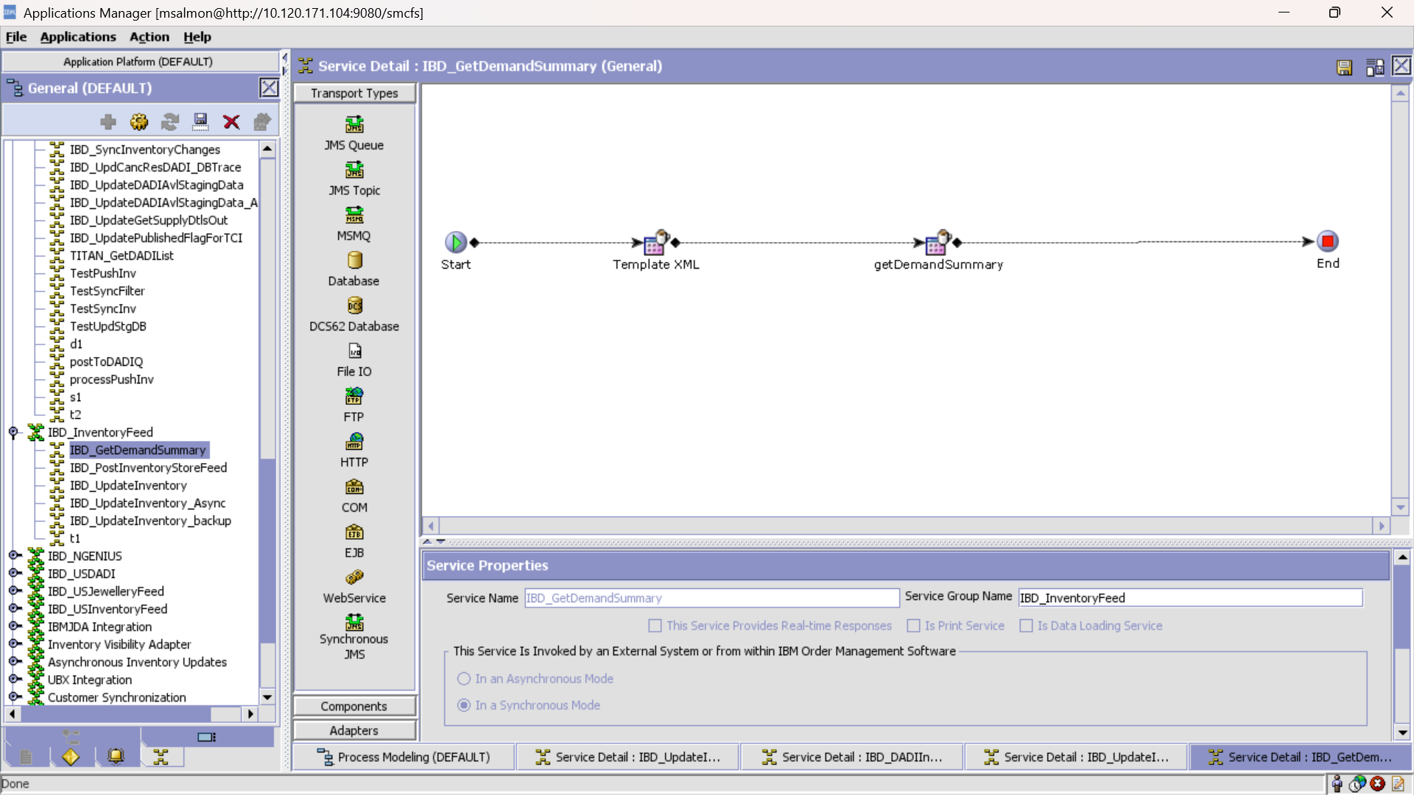

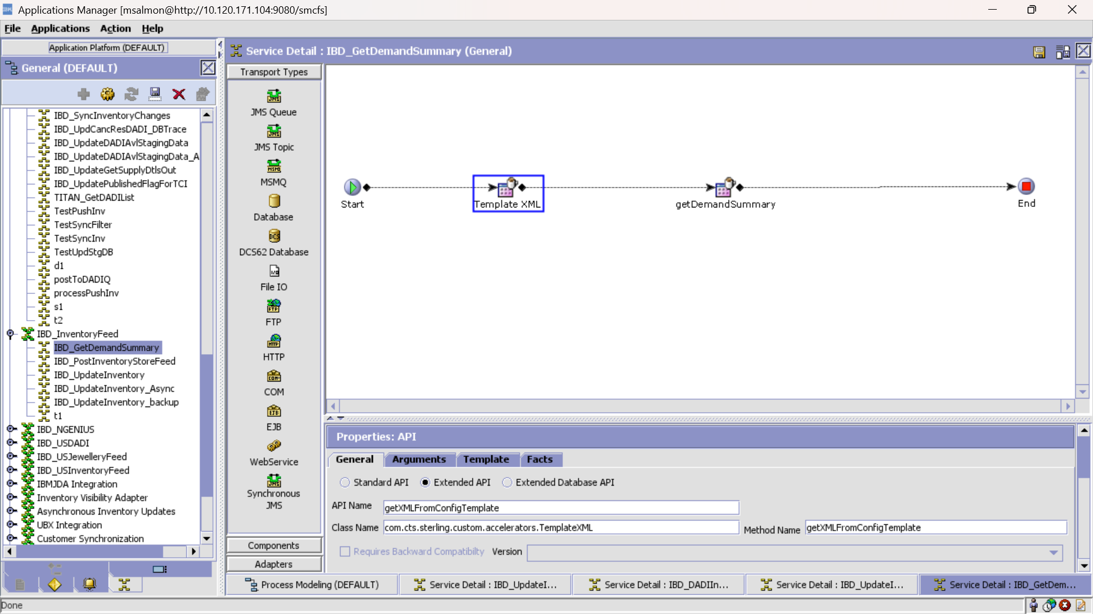

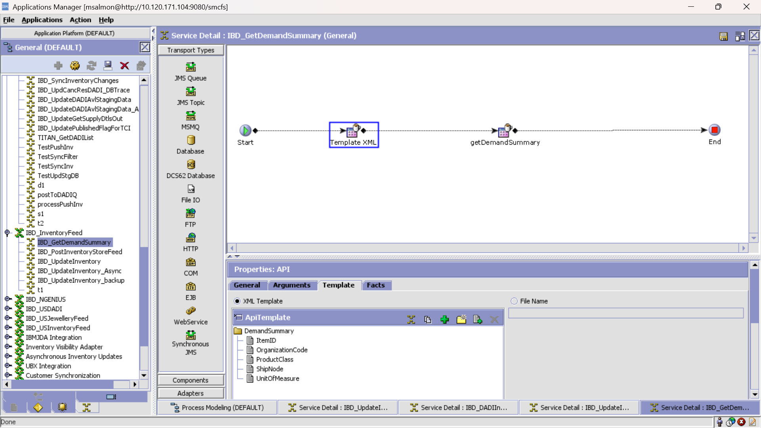

Template :

<?xml version="1.0" encoding="UTF-8"?>

<DemandSummary ItemID="/InventorySnapShot/ShipNode/Item/@ItemID"

OrganizationCode="/InventorySnapShot/@OrganizationCode"

ProductClass="FQ" ShipNode="/InventorySnapShot/ShipNode/@ShipNode" UnitOfMeasure="EACH"/>

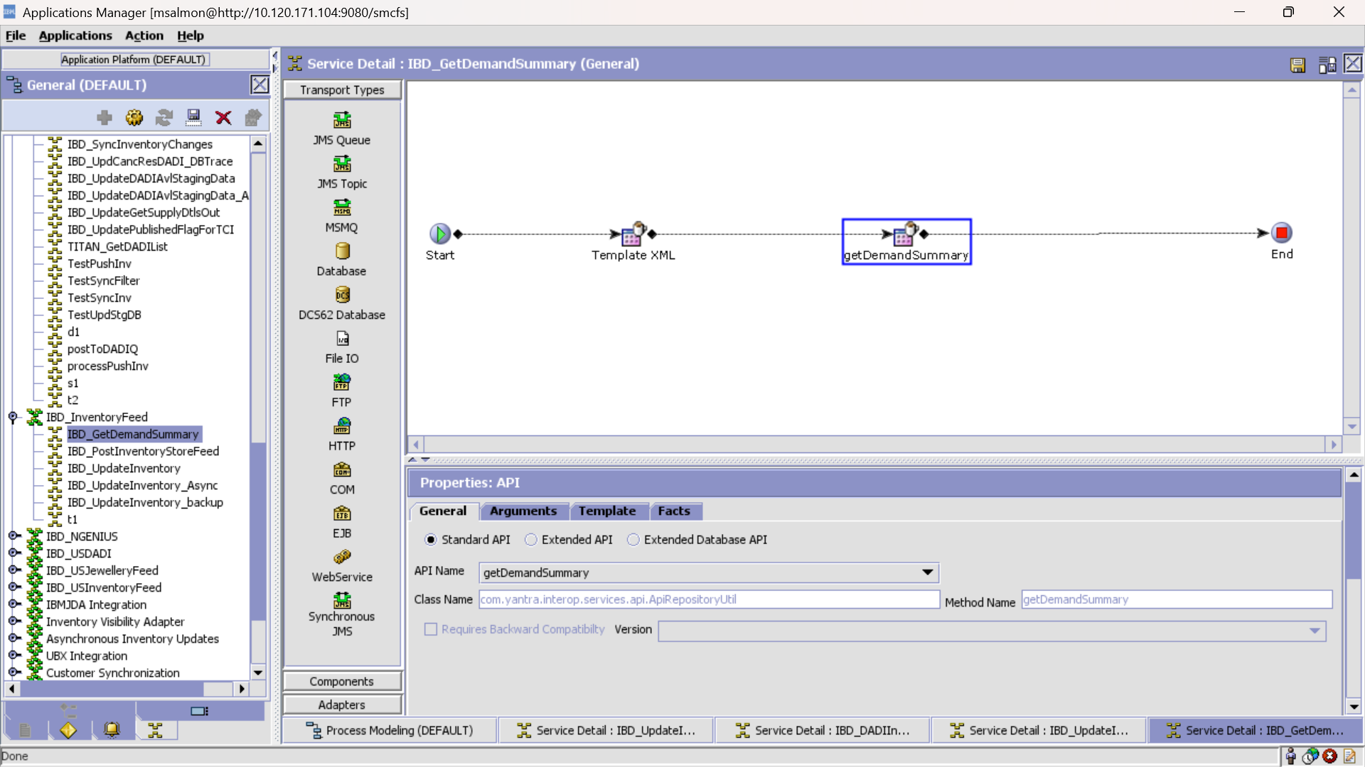

Service: IBD_DADIInsertJewDefaults

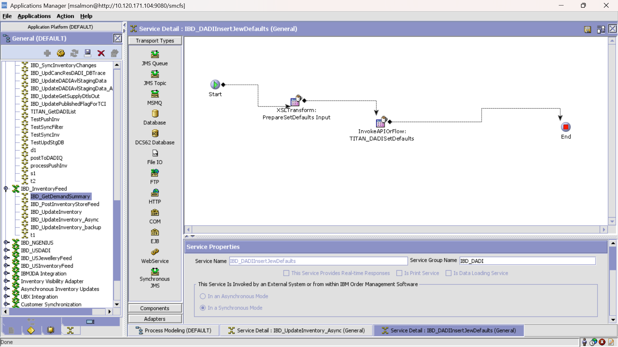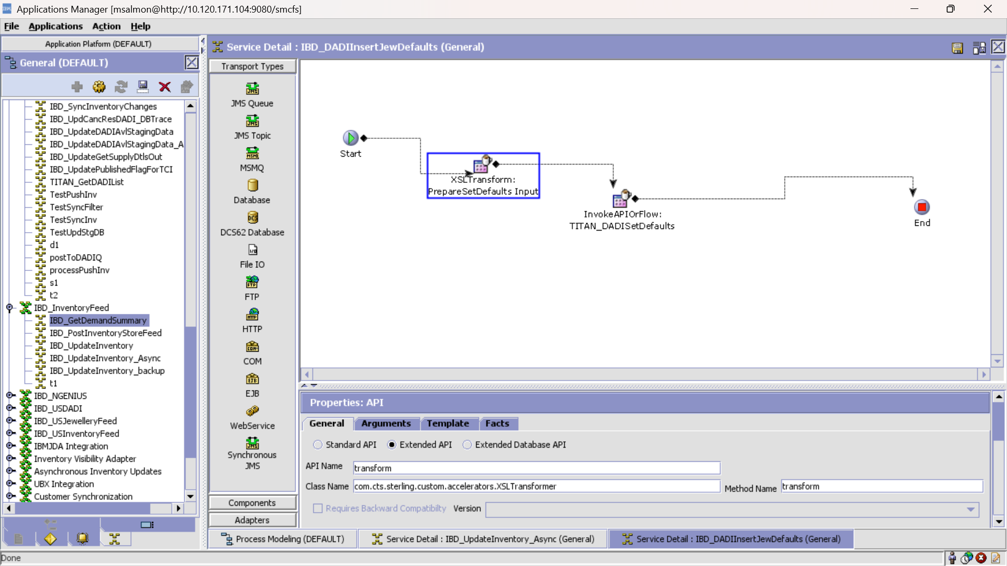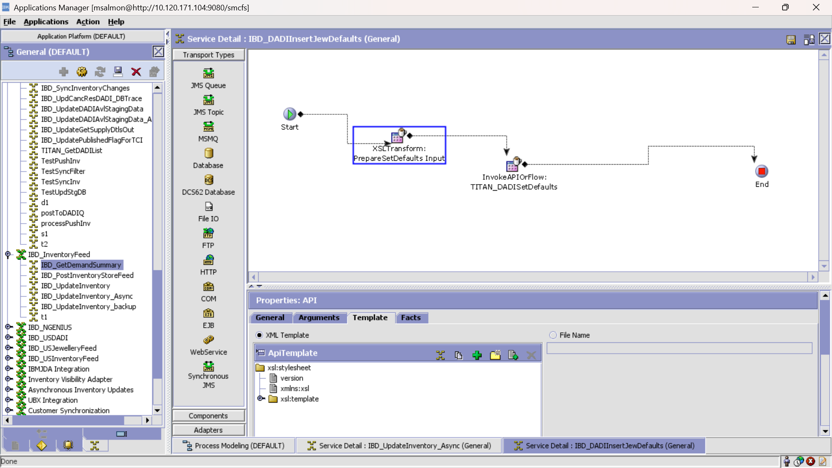XSL:

<?xml version="1.0" encoding="UTF-8"?>

<xsl:stylesheet version="1.0" xmlns:xsl="http://www.w3.org/1999/XSL/Transform">

<xsl:template match="/Items">

<Items>

<Item ItemID="{Item/@ItemID}" UnitOfMeasure="EACH">

<PrimaryInformation ProductLine="_DADI_FOR_JEW_"/>

</Item>

</Items>

</xsl:template>

</xsl:stylesheet>

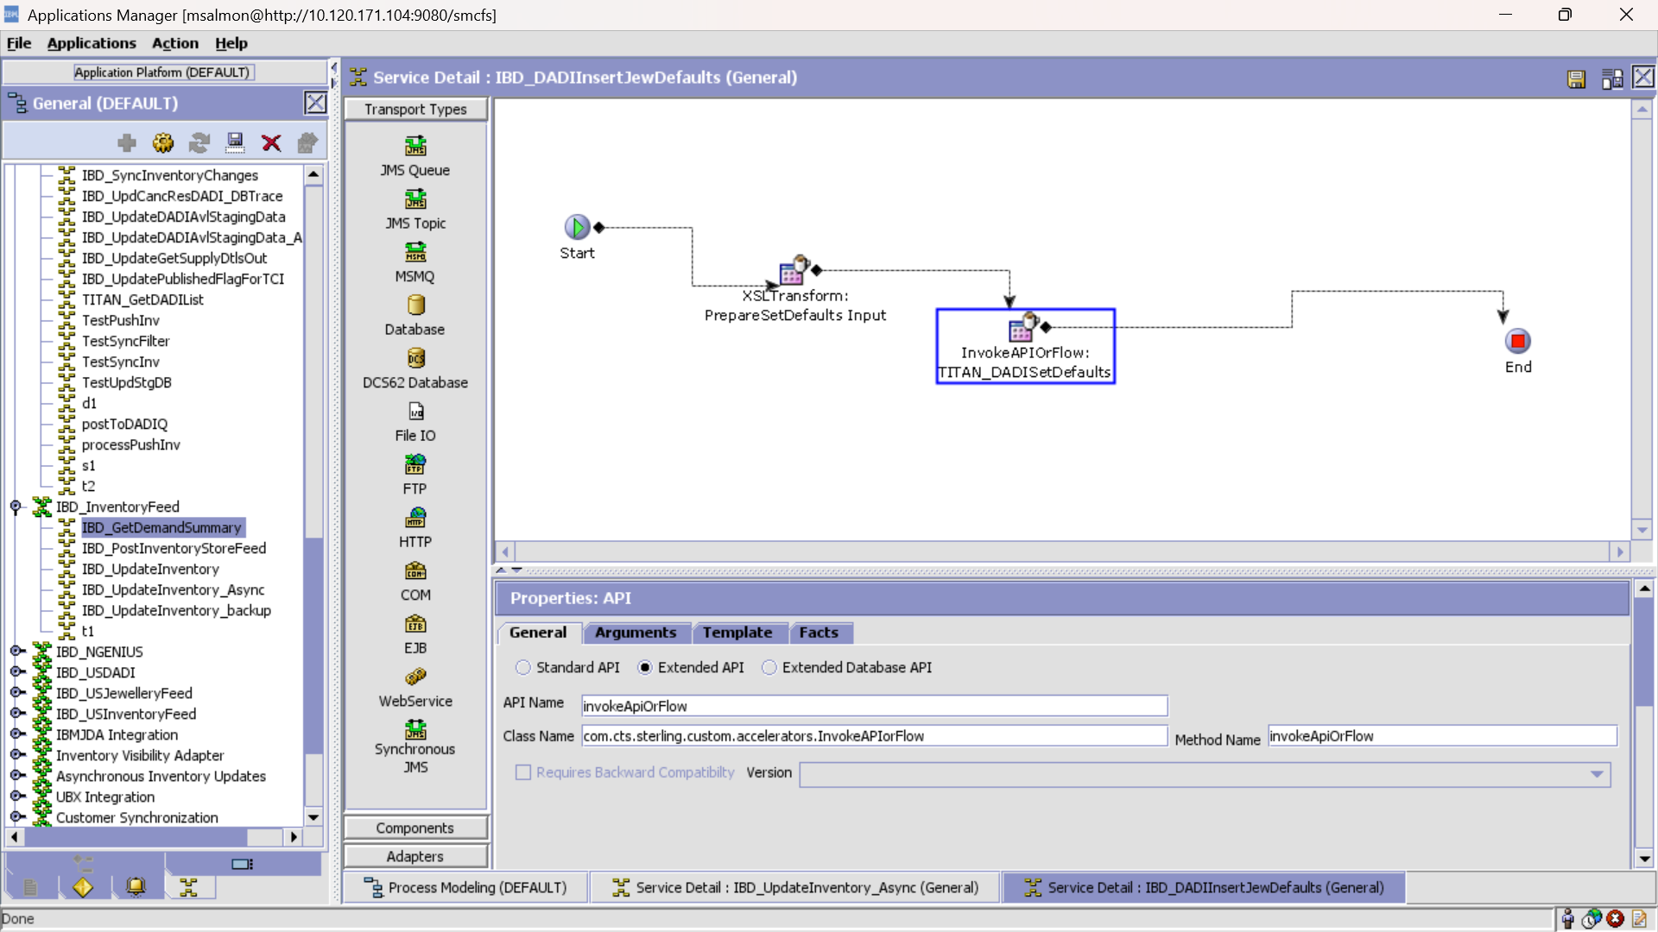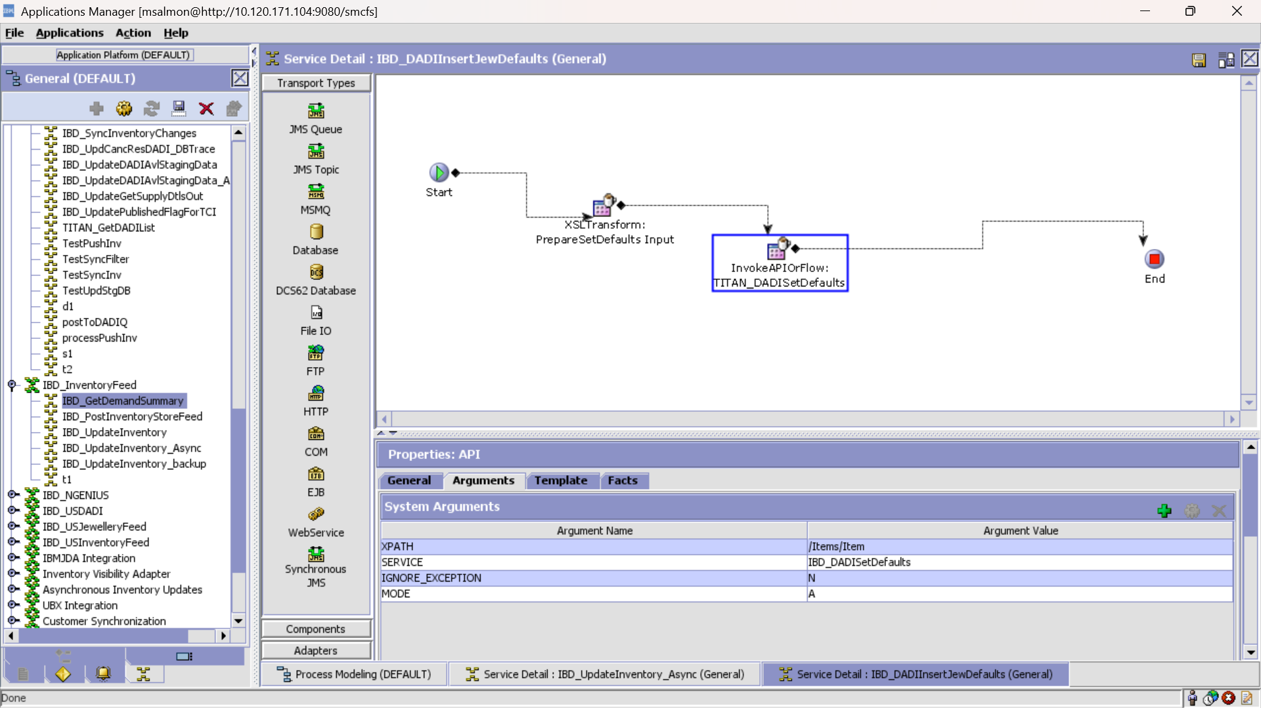 Service IBD_DADISetDefaults invoked here is defined below

Service: IBD_DADISetDefaults

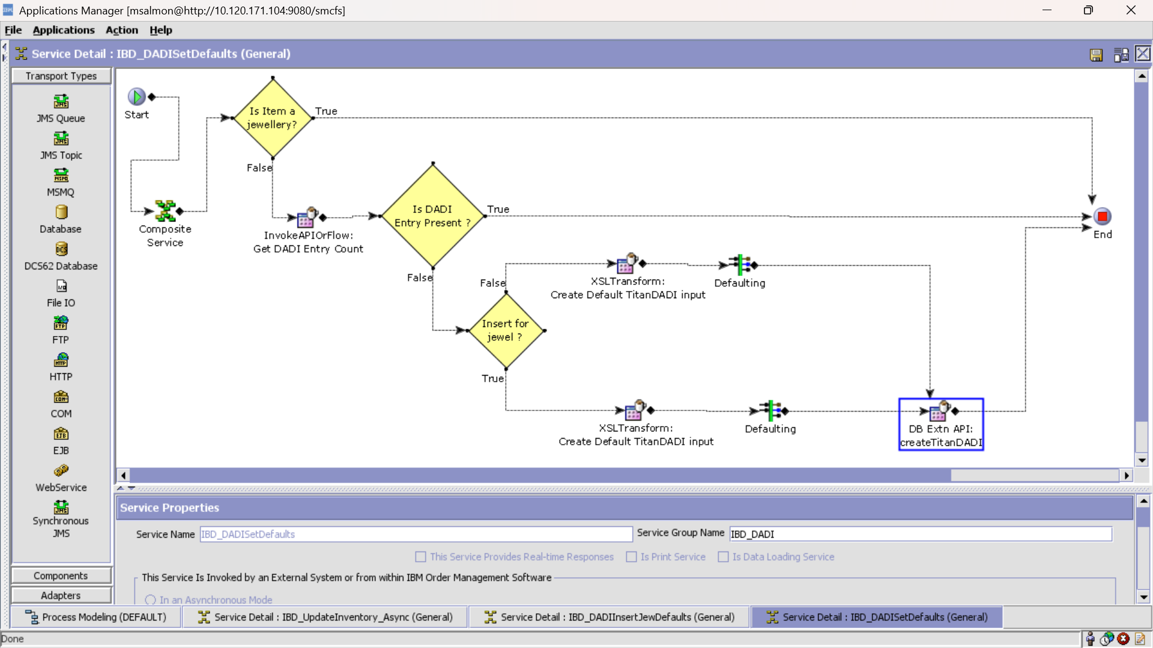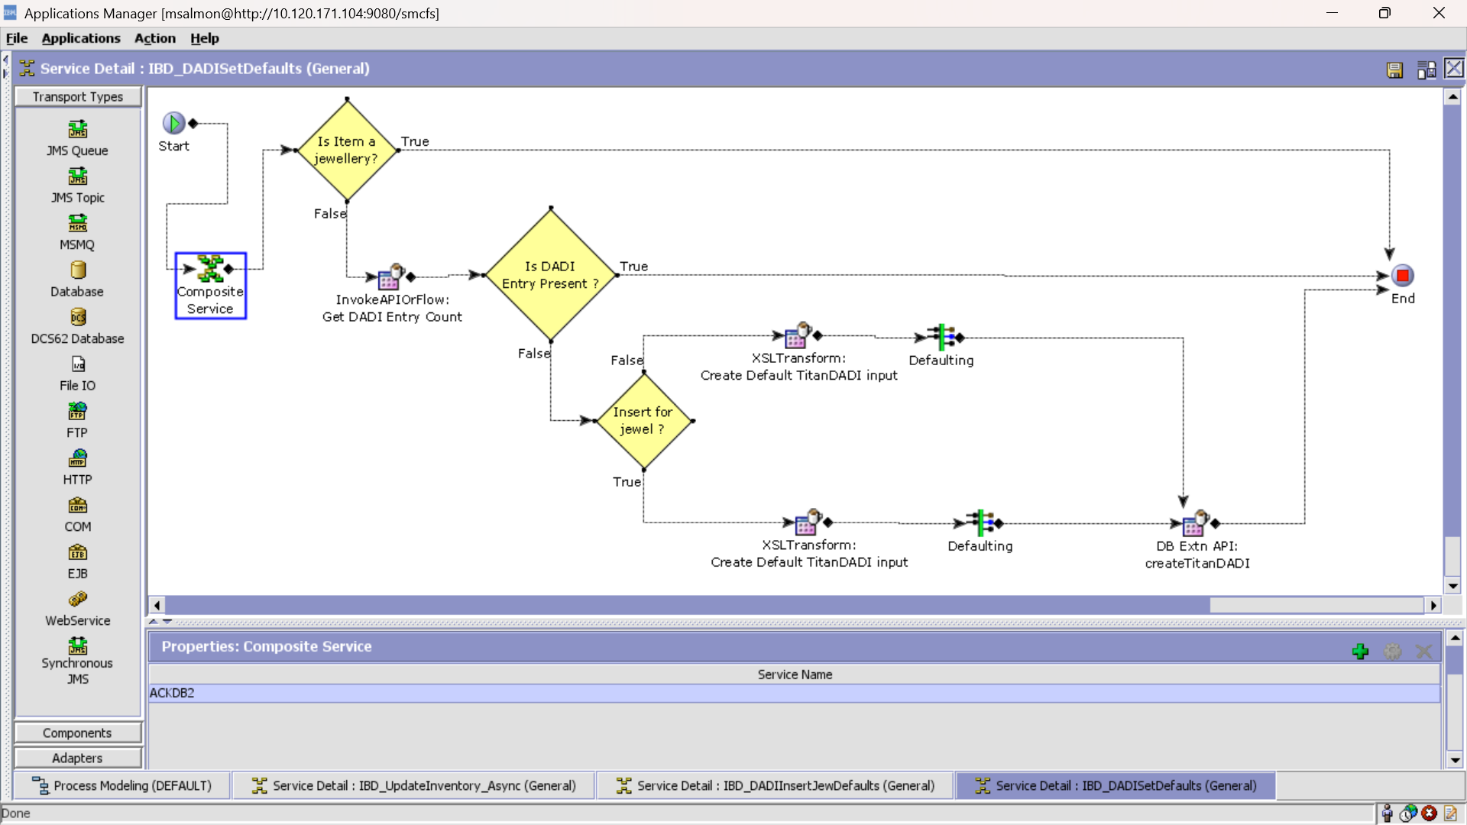

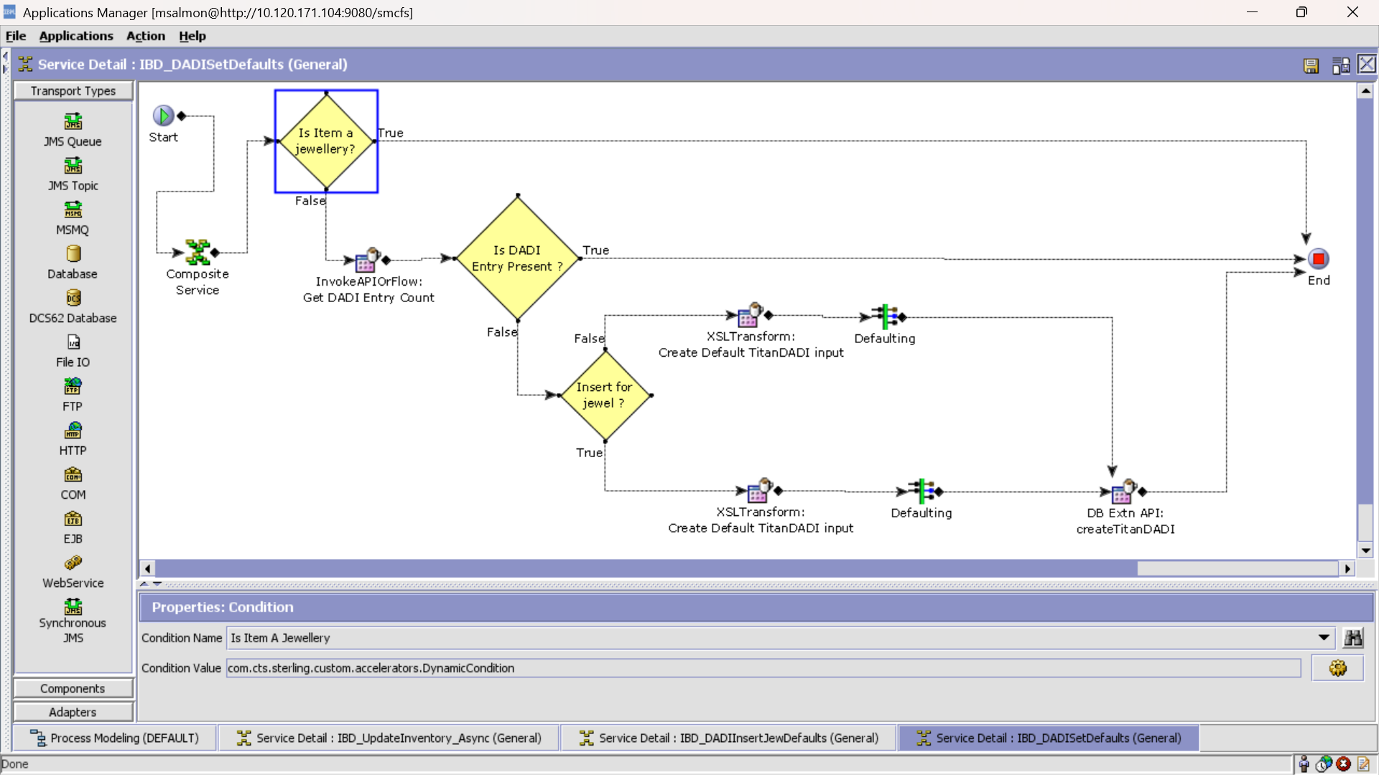Condition:

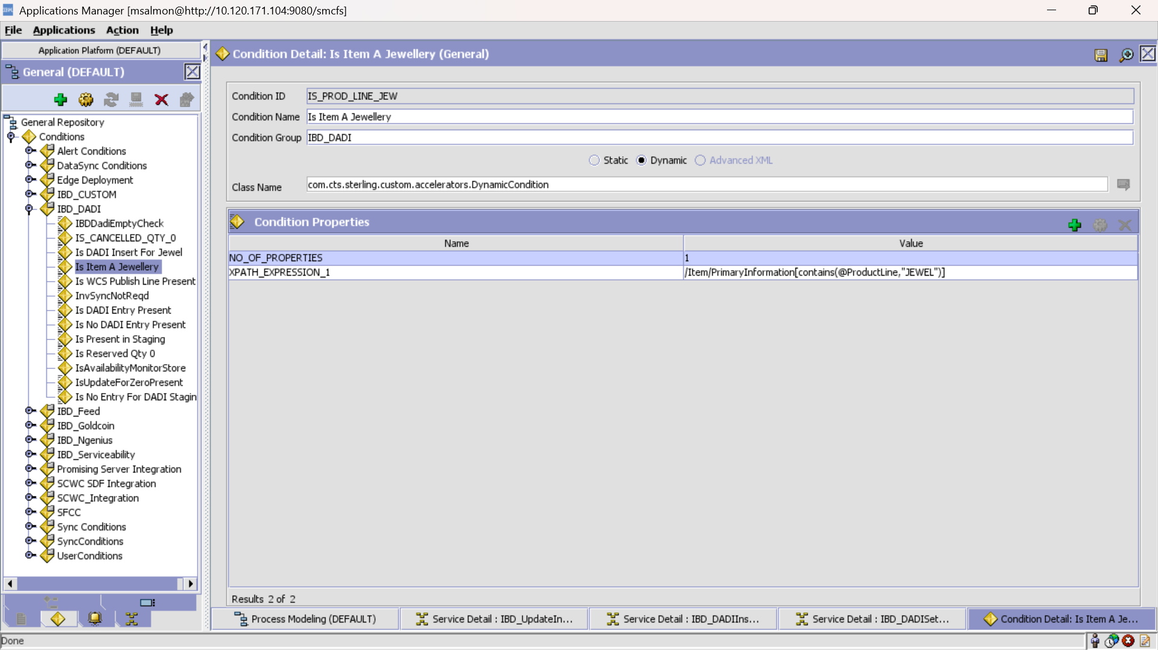

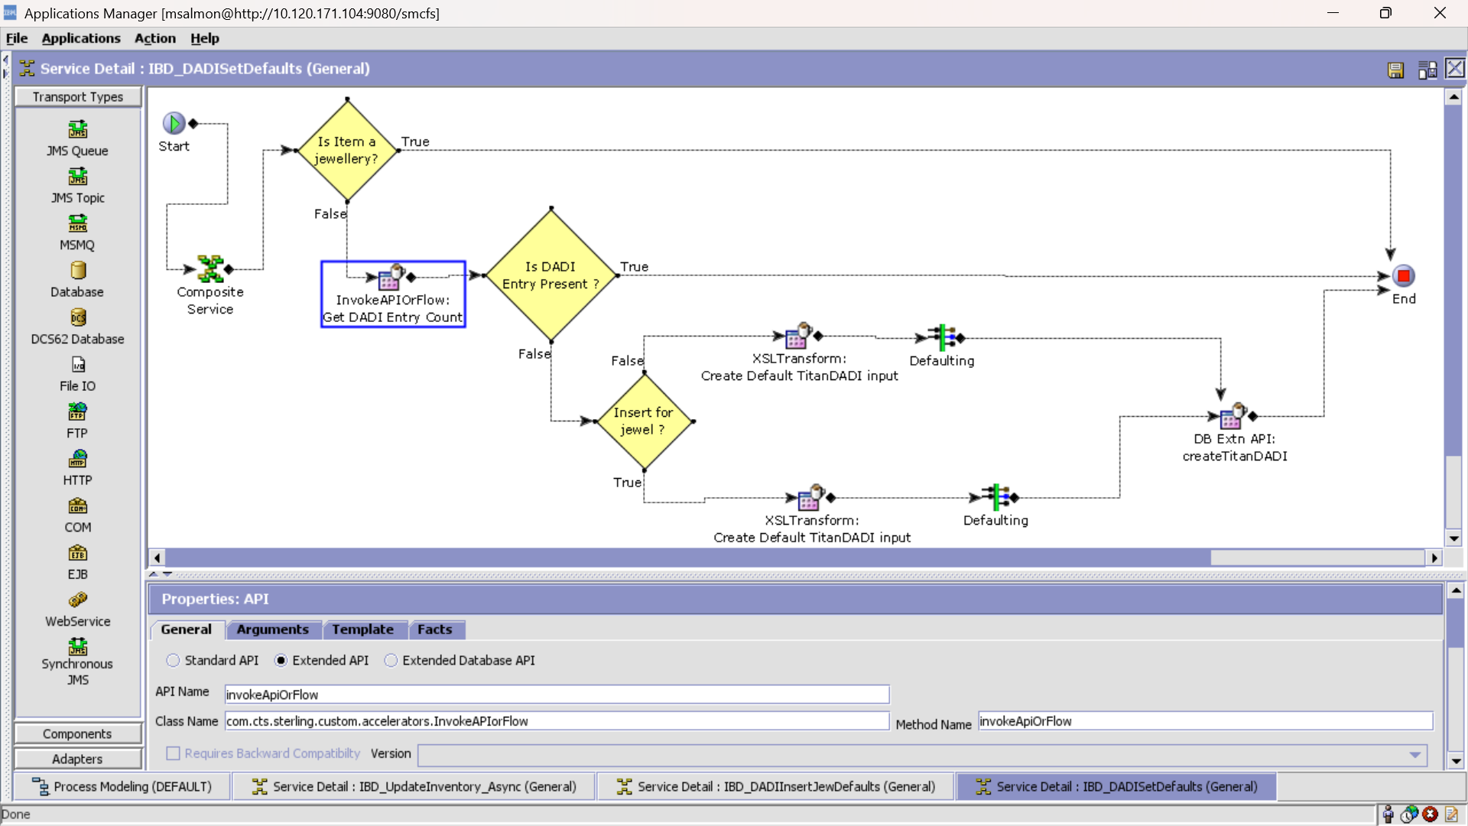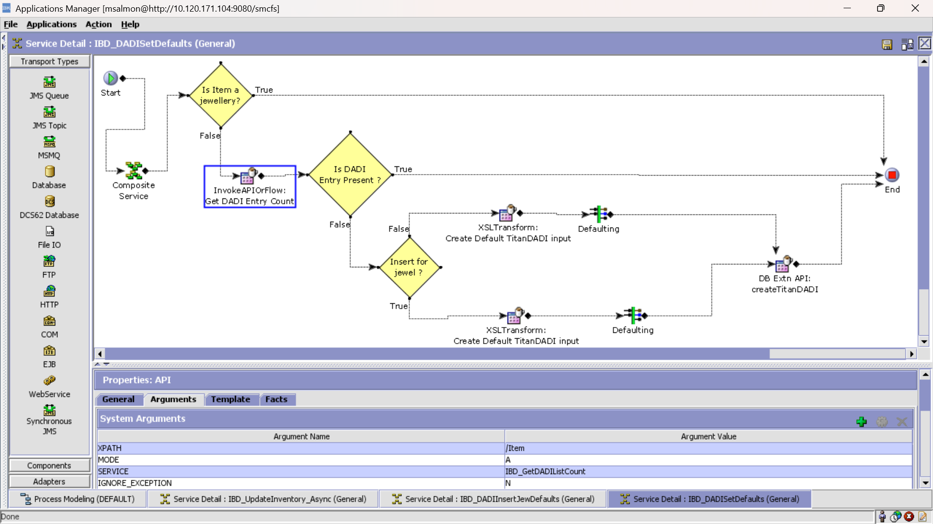Service IBD_GetDADIListCount invoked here is defined in page 32

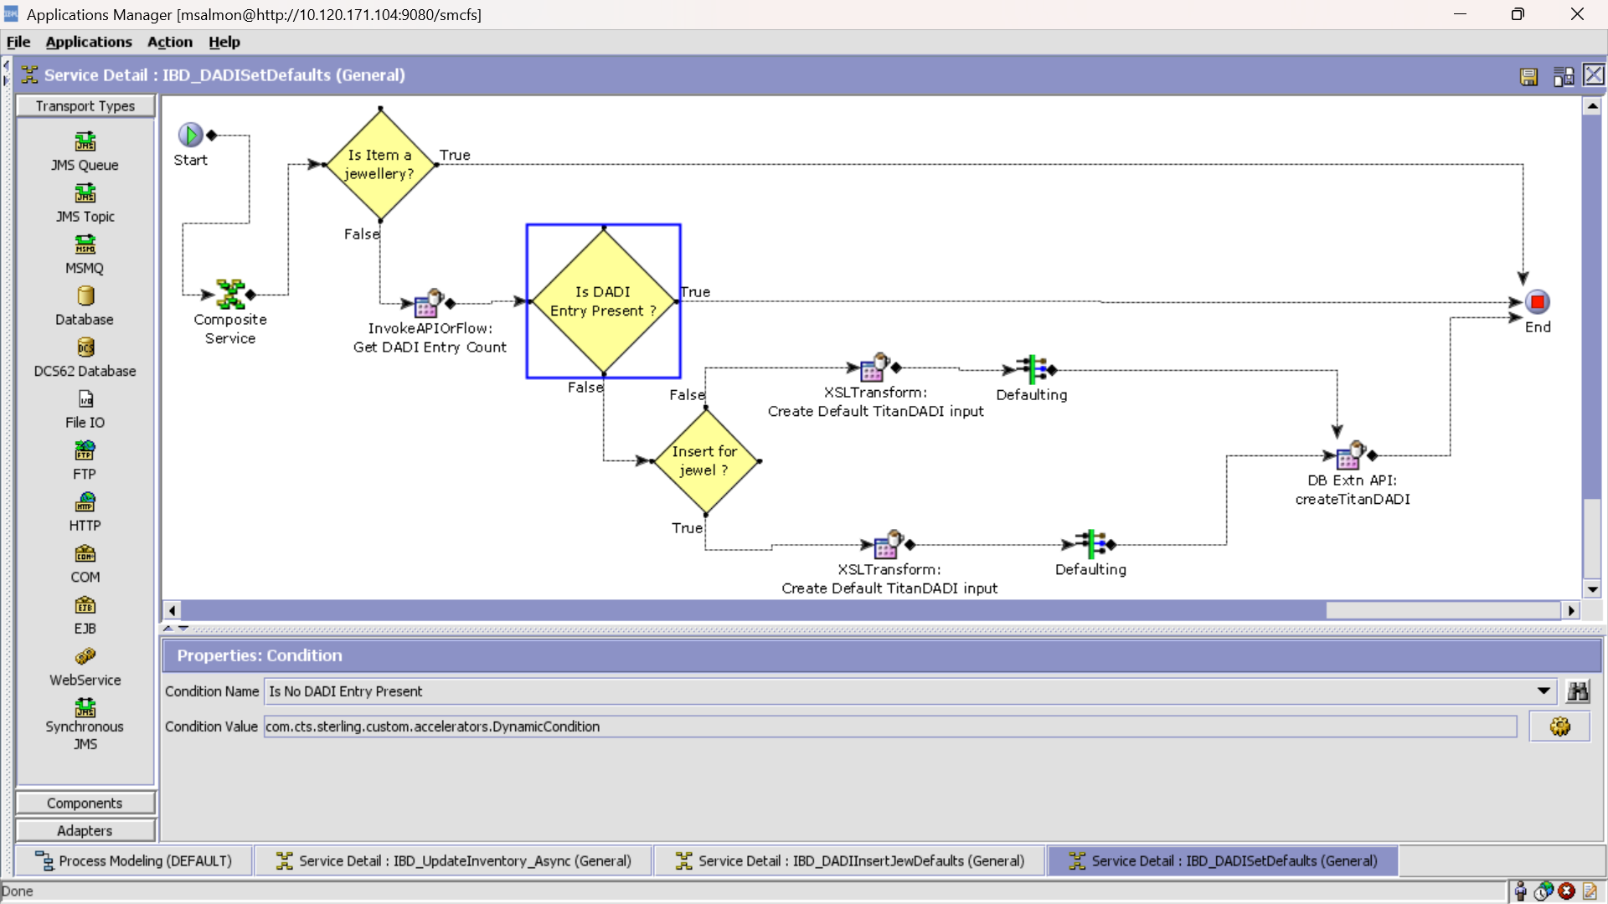Condition:

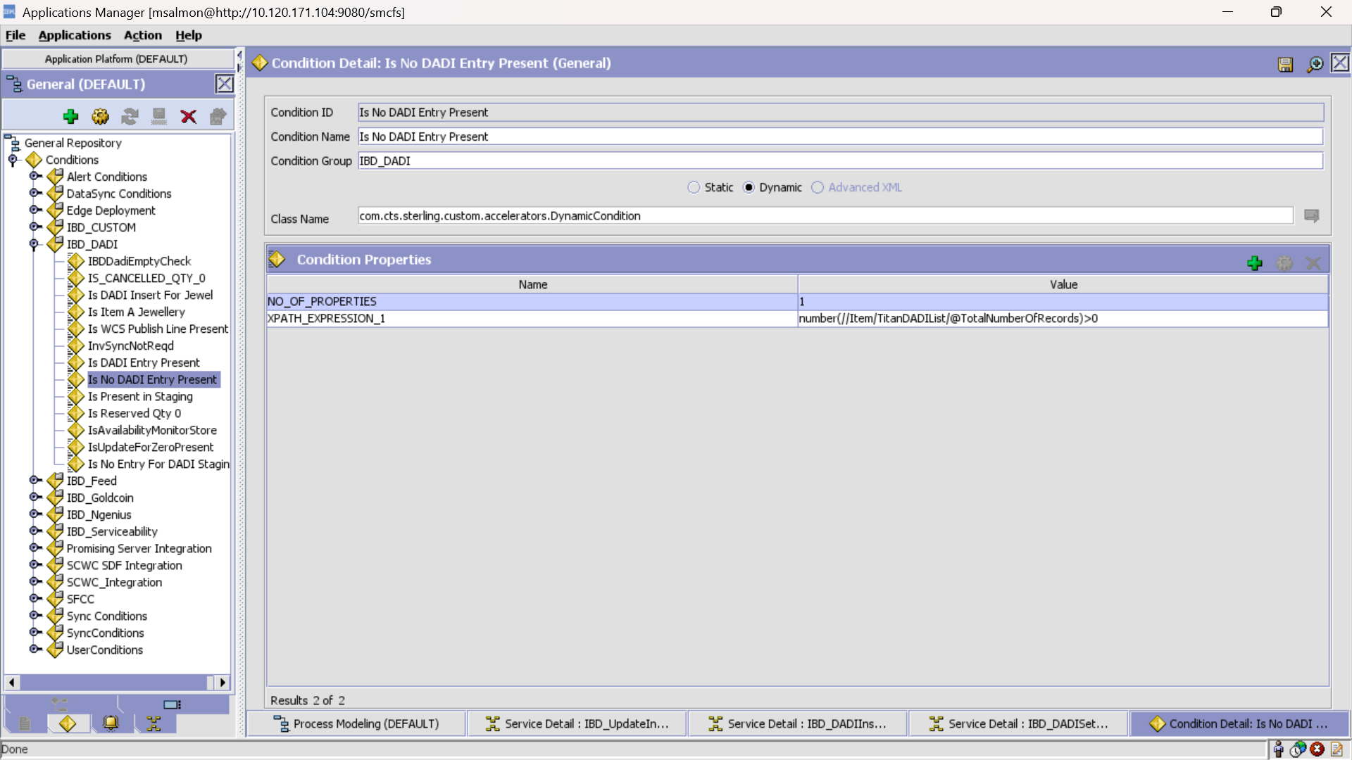

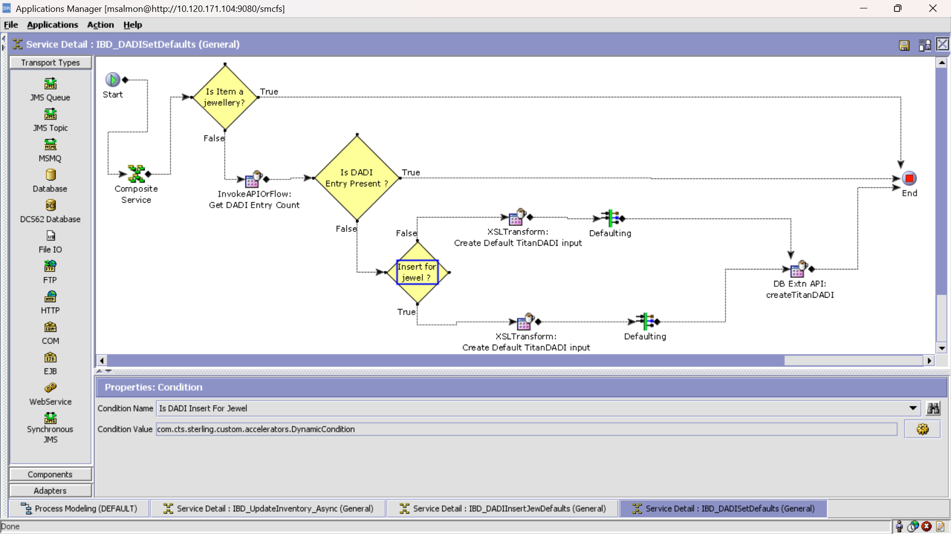Condition

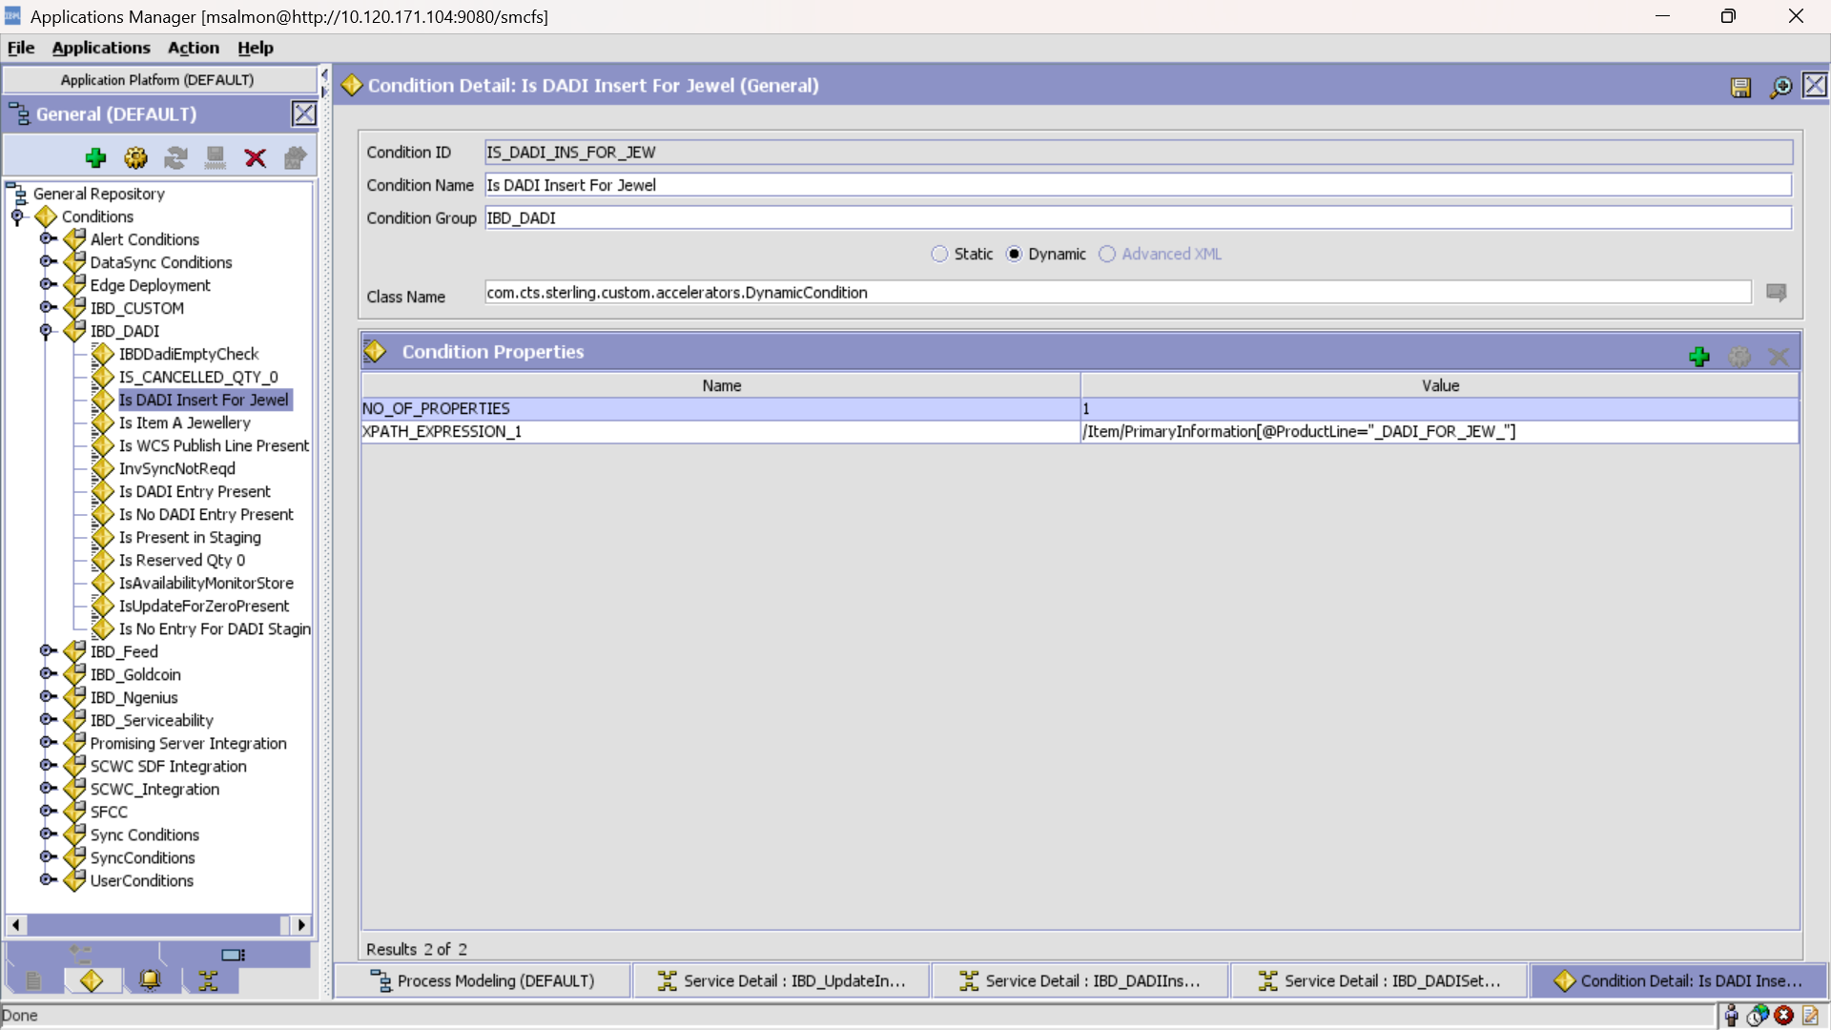

If true:

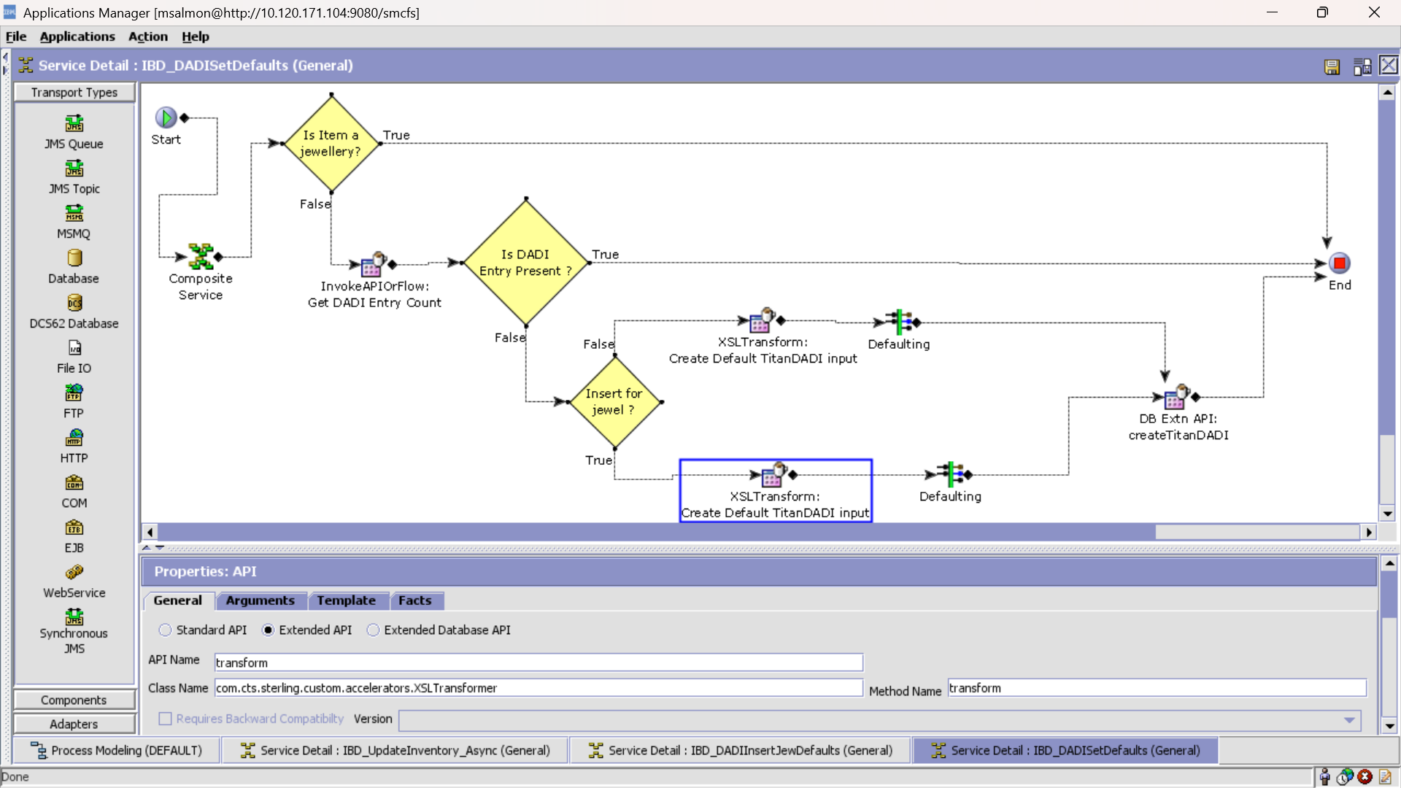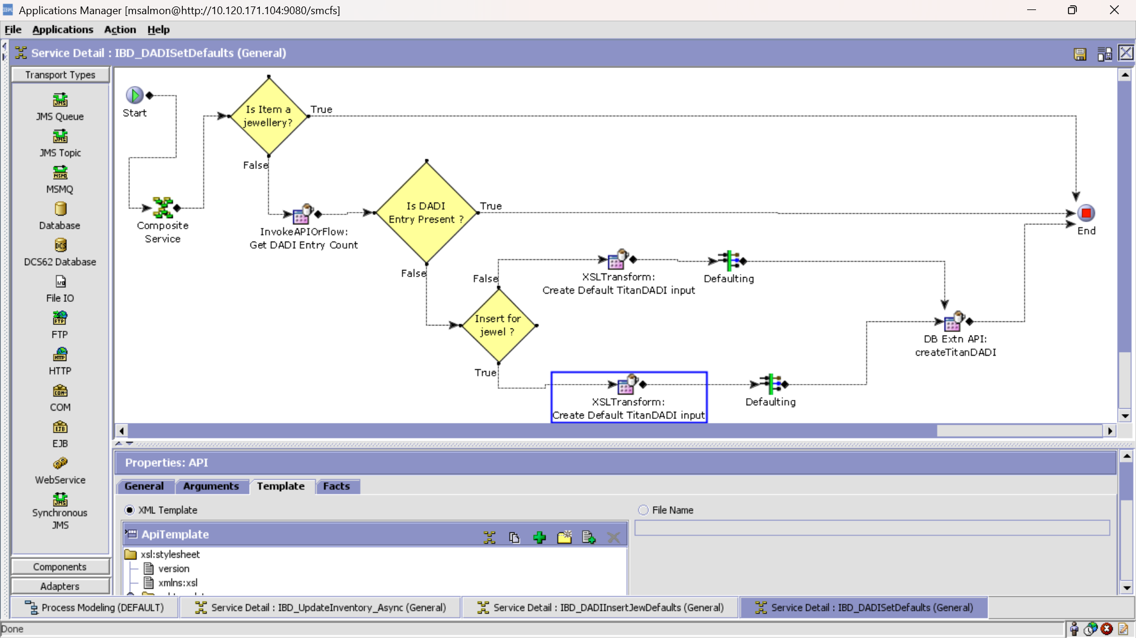

XSL:

<?xml version="1.0" encoding="UTF-8"?>

<xsl:stylesheet version="1.0" xmlns:xsl="http://www.w3.org/1999/XSL/Transform">

<xsl:template match="/Item">

<xsl:variable name="ItemID">

<xsl:value-of select="@ItemID"/>

</xsl:variable>

<TitanDADI ItemID="{$ItemID}" NodeType="Store"

TCIPercentage="100" TCIPriority="1" TCIProcurementSLA="1"/>

</xsl:template>

</xsl:stylesheet>

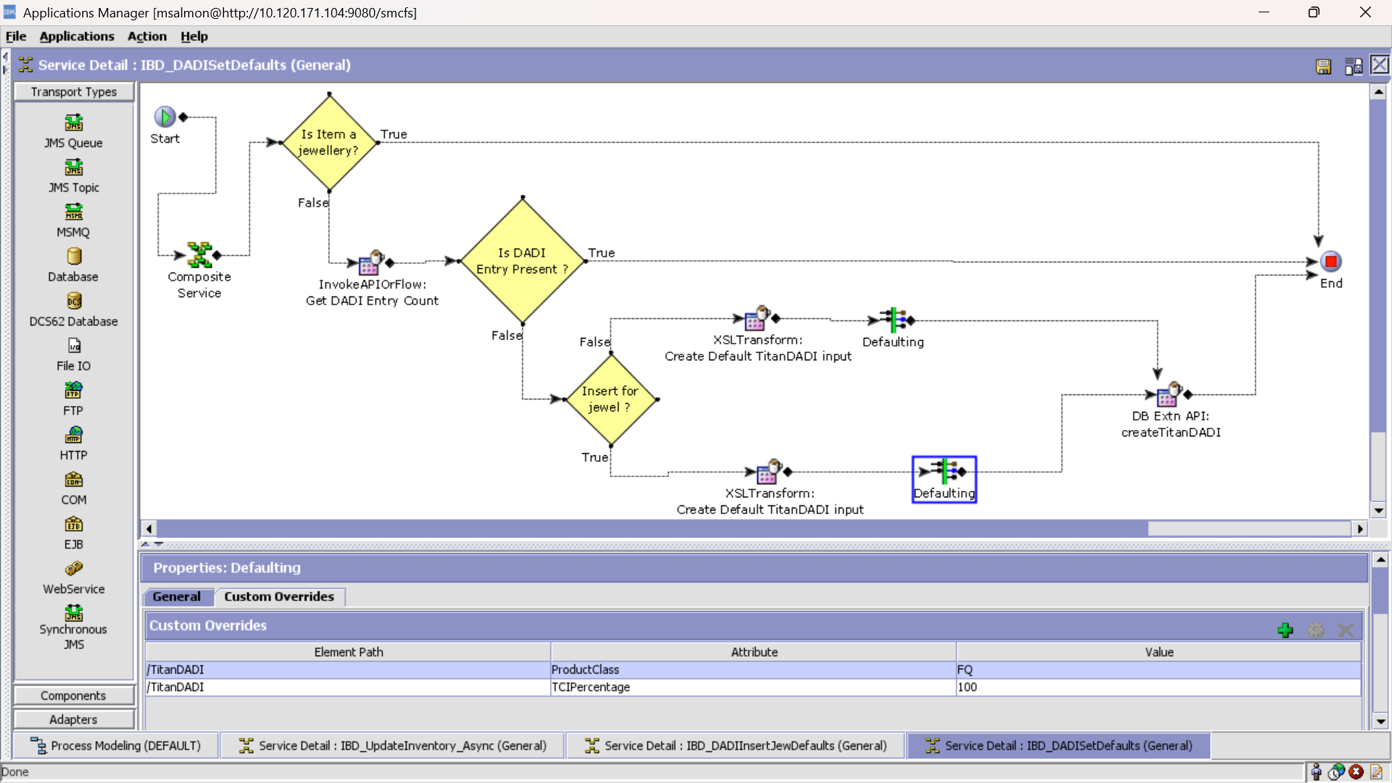

If False:

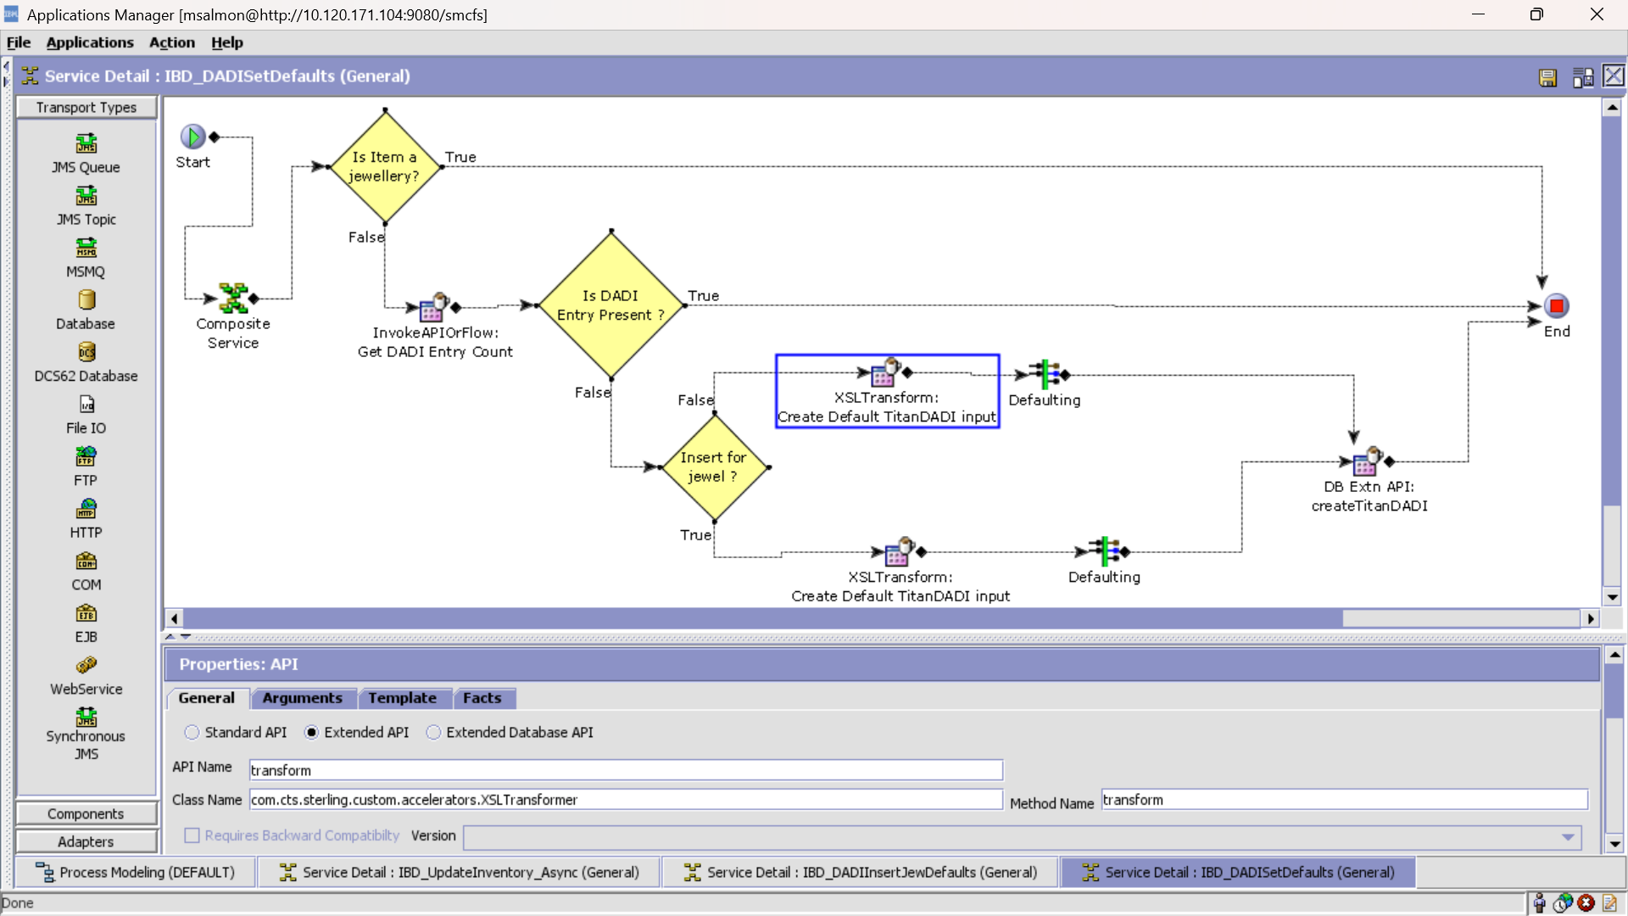

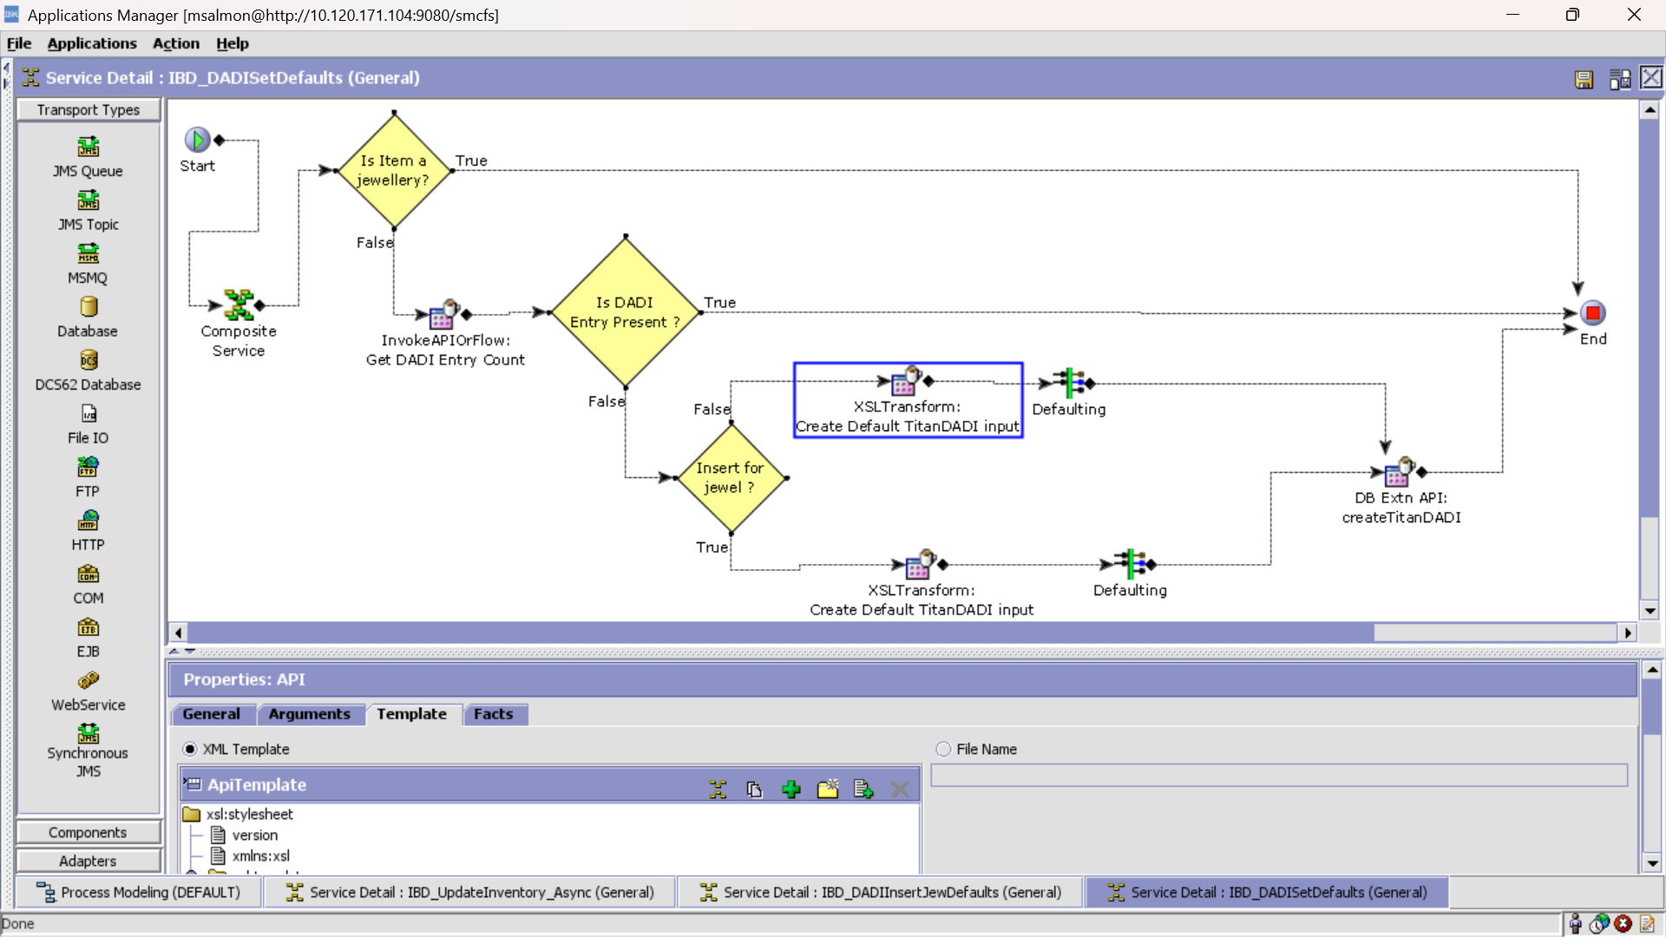

XSL:

<?xml version="1.0" encoding="UTF-8"?>

<xsl:stylesheet version="1.0" xmlns:xsl="http://www.w3.org/1999/XSL/Transform">

<xsl:template match="/Item">

<xsl:variable name="ItemID">

<xsl:value-of select="@ItemID"/>

</xsl:variable>

<TitanDADI ItemID="{$ItemID}" TCIPercentage="0" TCIPriority="1" TCIProcurementSLA="1"/>

</xsl:template>

</xsl:stylesheet>

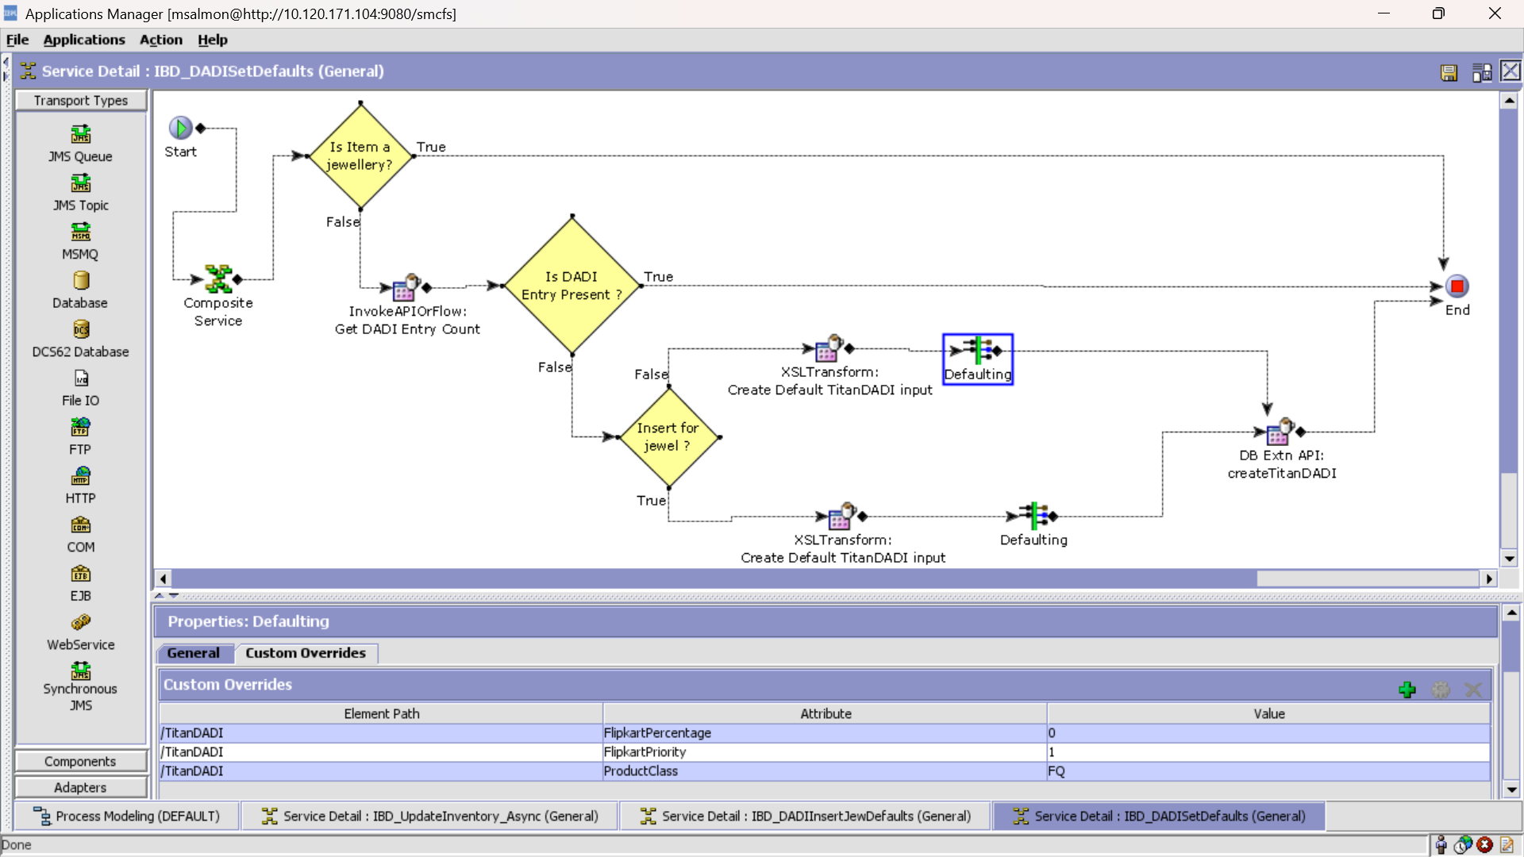

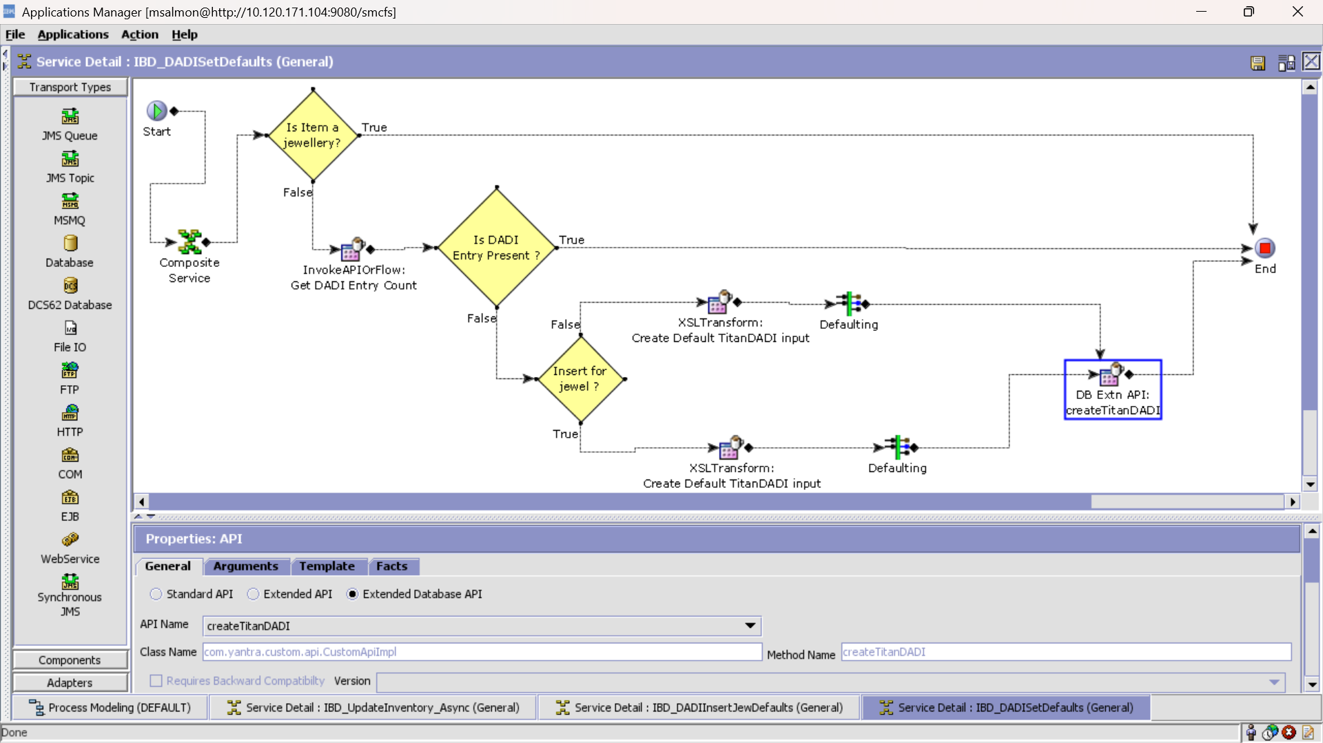

Service: IBD_GetDADIListCount

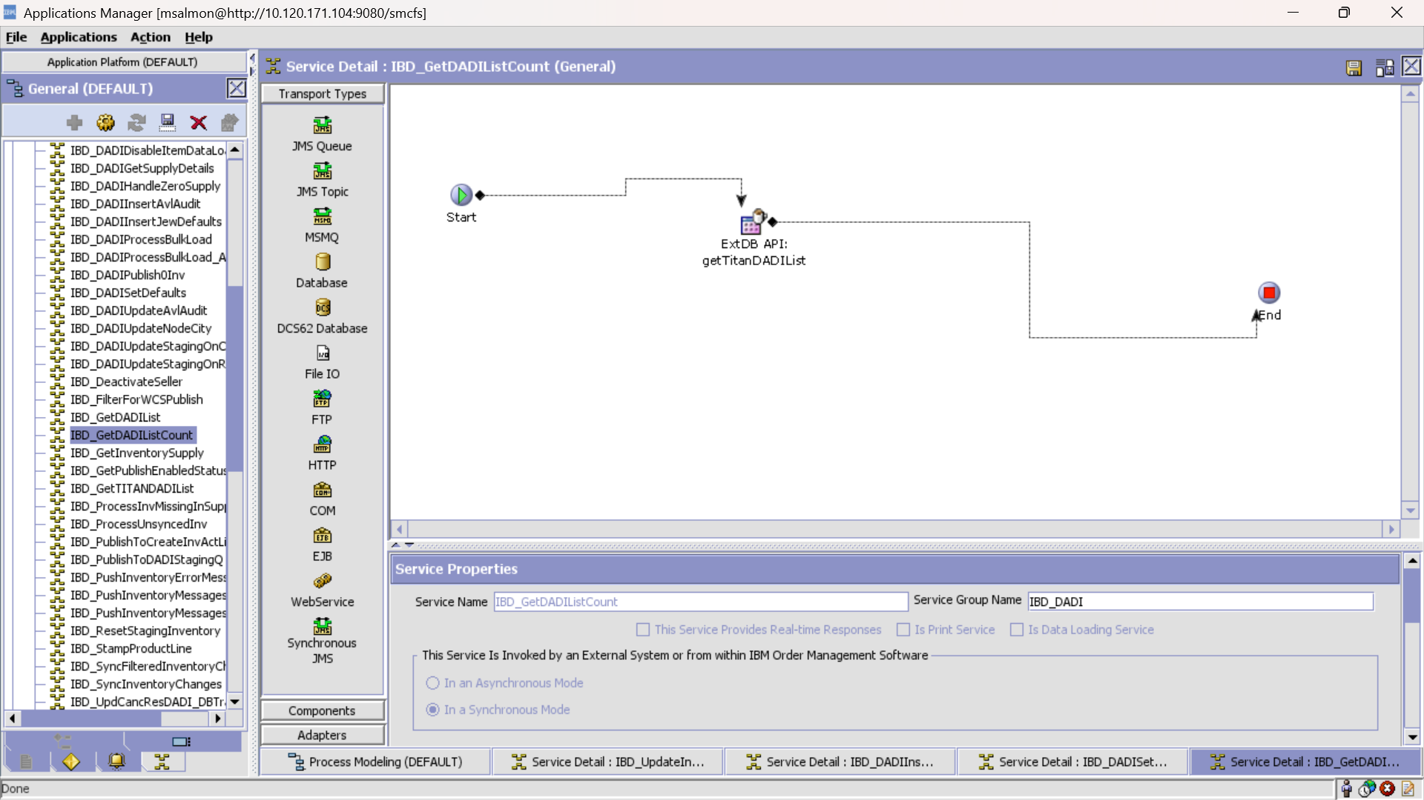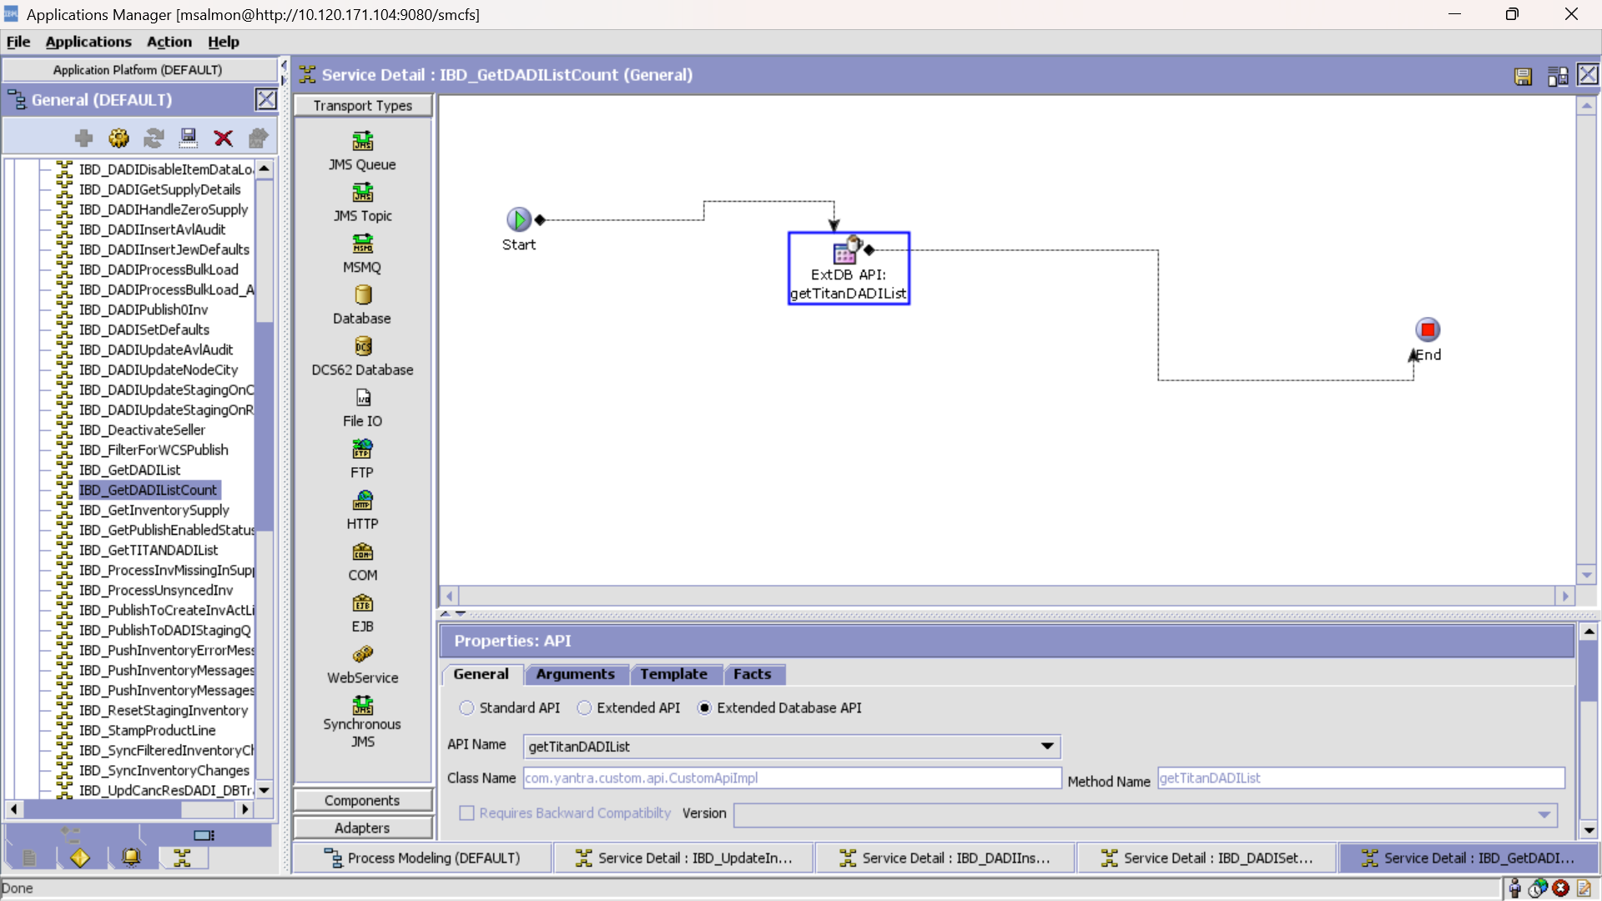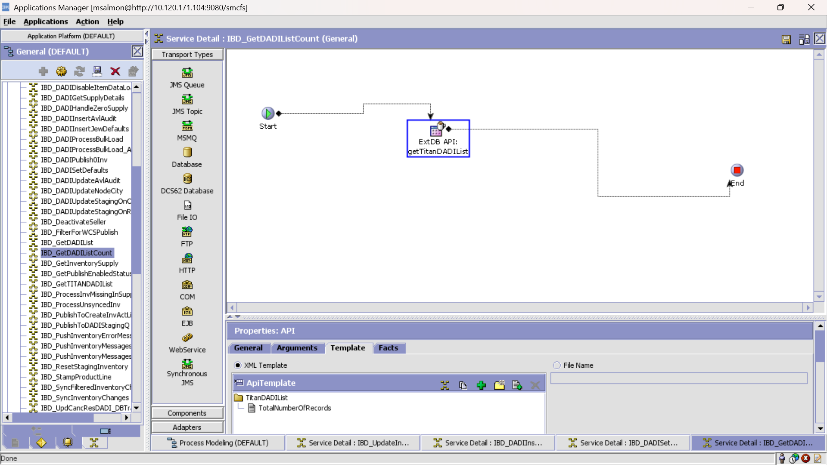

Template:

<?xml version="1.0" encoding="UTF-8"?>

<TitanDADIList TotalNumberOfRecords=""/>